Moduldokumentation

Modul Software Construction (swc)

Simon Wächter

2016

Inhalt

1 Einleitung 8

1.1 Einleitung 8

1.2 Lernziele 8

1.3 Prüfungen 8

2 Woche 1 9

2.1 Installation 9

2.2 Software Construction 9

2.2.1 Was ist Software Construction 9

2.2.2 Warum ist Software Construction so wichtig 9

2.2.3 Qualität als zentraler Faktor 9

2.2.4 Herausforderungen der Softwareentwicklung 10

2.2.5 Ziel der Software Construction 10

2.2.6 Infrastruktur für eine Softwareverwaltung 10

2.3 Versionsmanagement 10

2.3.1 Probleme und Herausforderungen 10

2.3.2 Definition einer Versionsverwaltung 11

2.3.3 Projektobjekte für eine Versionsverwaltung 11

2.4 Konzepte des Versions- und Release-Management 11

2.4.1 Über Versionen und Releases 11

2.4.2 Typische Release- und Versionsidentifikationen 12

2.5 Versionskontrollsysteme 12

2.5.1 Allgemeine Begriffe und Konzepte 12

2.5.2 Zentralisierte versus Verteilte Kontrollsysteme 13

3 Woche 2 15

4 Woche 3 16

5 Woche 4 17

5.1 Automation 17

5.1.1 History 17

5.1.2 Description 17

5.1.3 Why should we care 17

5.1.4 Build Automation Procedures 17

5.1.5 Automation Prerequisites 18

5.1.6 CRISP Builds 18

5.2 Build tools 18

5.3 Maven 18

5.3.1 What is Maven 18

5.3.2 Maven Core Concepts 18

5.3.3 What Maven does 18

5.3.4 The Project Object Model (POM) 19

5.3.5 POM Sample 20

5.3.6 Dependency Management 20

5.3.7 Local Repository 21

5.3.8 Life Cycle, Phases and Goals 21

5.3.9 Default Life Cycle 22

5.3.10 Plugins 22

5.3.11 Properties 23

5.4 Drawbacks of Maven 23

5.5 Maven Best Practices 23

6 Woche 5 24

7 Woche 6 25

8 Woche 7 26

8.1 Continuous Integration 26

8.1.1 Integration 26

8.1.2 Integration Challenges 26

8.1.3 Broken Integration 26

8.1.4 Manual Integration 26

8.1.5 Definitions of Continuous Integration 27

8.1.6 Practices of Continuous Integration 27

8.1.7 Embrace Continuous Integration 27

8.1.8 Continuous Integration Prerequisites 27

8.1.9 Continuous Integration Infrastructure 28

8.1.10 Realizing Continuous Integration 28

8.1.11 What is a successful Build? 28

8.2 The Agile Process 29

8.2.1 Overview 29

8.2.2 Continuous Integration Benefits 29

8.2.3 Continuous Integration Obstacles 29

8.3 Jenkins as Continuous Integration Tool 29

8.3.1 Overview 29

8.3.2 Features 30

8.3.3 Components 30

8.3.4 Add-Ons 30

8.3.5 Other Continuous Integration Tools 30

8.4 Summary 30

9 Woche 8 31

9.1 Why should I care about Coding Style? 31

9.2 The cost of a mess 31

9.3 Definition of clean code 31

9.4 Code Rules 31

9.4.1 Meaningful Names 31

9.4.2 Clean Formatting 32

9.4.3 Vertical Formatting 32

9.4.4 Vertical openness between concepts 32

9.4.5 Vertical Density 32

9.4.6 Vertical Distance and Ordering 33

9.4.7 Horizontal Openness and Density 33

9.4.8 Team Rules 34

9.5 Code Checking 34

9.5.1 Apply and Check Code Conventions 34

9.5.2 Check Code with Checkstyle 34

9.6 Code Documentation 35

9.6.1 Clean Documentation 35

9.6.2 API Documentation is a contract 35

9.6.3 Class and Interface Documentation 35

9.6.4 Method Documentation 35

9.6.5 When to write API documentation 36

9.6.6 Rules for Writing Summaries 36

9.6.7 Clean (Internal comments) 36

9.7 Javadoc 36

9.7.1 Overview 36

9.7.2 Tags 37

9.7.3 Comments 37

9.7.4 Hints 37

9.8 Clean Coding 38

9.8.1 General 38

9.8.2 Writing Functions 38

9.8.3 Negative Conditionals 39

9.8.4 Arguments 39

10 Woche 9 40

10.1 Software Problems 40

10.1.1 Famous Software Failures 40

10.2 Software Testing and Failures 40

10.2.1 Why does testing matter? 40

10.2.2 Terms 40

10.2.3 What is a Defect? 40

10.2.4 Fault, Errors, Failure 40

10.2.5 From Defect to Failure 41

10.2.6 So what is Testing? 41

10.2.7 Regression Testing 42

10.2.8 The Testing Process 42

10.2.9 Unit Testing 42

10.3 Unit Testing 43

10.3.1 Unit Testing Frameworks 43

10.3.2 JUnit 43

10.3.3 Organizing Tests 46

10.3.4 Bad Excuses 46

11 Woche 10 48

11.1 Good tests 48

11.1.1 Good Tests 48

11.1.2 What to tests? 48

11.1.3 How much to test? 48

11.1.4 How much to test – the challenge 49

11.2 Testing Techniques 49

11.2.1 Determining Test Data 49

11.2.2 Equivalence Classes 49

11.2.3 Boundary Value Analysis 50

11.2.4 Acronym Right BICEP 52

11.2.5 Test First 54

11.3 Writing Testable Code 55

11.3.1 What is testable Code? 55

11.3.2 Some more Terms 55

11.3.3 Fixtures 55

11.3.4 Fixture 56

11.3.5 Testing in Isolation 56

12 Woche 11 57

12.1 Unit Testing 57

12.1.1 Unit Testing 57

12.1.2 Limits of Unit Testing 57

12.2 Mocking 57

12.2.1 Test Isolation 57

12.2.2 Test Double 57

12.2.3 Test Doubles in Unit Testing 58

12.2.4 Testing with Stubs 58

12.2.5 Sample Application 59

12.2.6 Mock Testing 59

12.2.7 When to Use Mock Objects 59

12.2.8 Pros and Cons of Mock Objects 59

12.3 Mock Framework Mockito 59

12.3.1 Overview 59

12.3.2 Using Mockito 60

12.3.3 Mocking Usage Pattern 60

12.3.4 Create Mock 61

12.3.5 Specifiy Method Behaviour 61

12.3.6 Use Mock Objects 61

12.3.7 Verify Behavior 62

12.3.8 Mockito Benefits 62

12.3.9 Further Concepts 62

13 Woche 12 63

14 Woche 13 64

15 Woche 14 65

16 Woche 15 66

16.1 Code Quality 66

16.1.1 What is Software Quality 66

16.1.2 Software Quality Goals – Beware 66

16.1.3 Software Quality - Management 66

16.2 Metric Data 67

16.2.1 Metric: A Definition 67

16.2.2 What Can We Measure 67

16.2.3 Some Static Software Metrics 67

16.2.4 Some Dynamic Software Metrics 68

16.2.5 What else we can measure 68

16.2.6 Cyclonic Complexity (McCabe) 69

16.2.7 Cohesion and Coupling Metrics 69

16.2.8 LCOM 69

16.2.9 Measure What You Test 70

16.2.10 Measurements Units 70

16.3 Tools 70

16.3.1 Some Sample Figures 70

16.3.2 How is coverage measured 71

16.3.3 Instrumentation 71

16.3.4 Code Coverage with Emma 71

16.3.5 Emma Features 72

16.3.6 Using Metrics 72

16.3.7 Resources 72

17 Woche 16 73

17.1 Refactoring 73

17.1.1 Improving Code 73

17.1.2 If it stinks, change it 73

17.1.3 How do I find Code Smells? 73

17.1.4 Some Typical Code Smells 74

17.1.5 Why Refactoring 74

17.1.6 Benefits of Refactoring 74

17.1.7 Prerequisites for Refactoring 75

17.1.8 The Two Hats 75

17.1.9 Refactoring Workflow 75

17.1.10 When 76

17.1.11 Problems with Refactoring 76

17.1.12 Resources 76

18 Woche 17 77

18.1 Logging 77

18.1.1 Why logging? 77

18.1.2 Value of Logging 77

18.1.3 Approaches to Logging 77

18.1.4 Benefits Using Logging Frameworks 78

18.2 The log4j Framework 78

18.2.1 Overview 78

18.2.2 Example 78

18.2.3 Concepts 79

18.2.4 Logging Levels 79

18.2.5 Logging API 79

18.2.6 Loggers, Appenders and Layouts 80

18.2.7 Logger Names 80

18.2.8 Benefits of using Fully Qualified Class Names 80

18.2.9 Rooter Logger 80

18.2.10 Appenders 81

18.2.11 Pattern Layout – Customize your Message Format 81

18.2.12 Sample log4j.properties 81

18.2.13 Sample log4j.xml 81

18.2.14 Cost of Logging 82

18.2.15 Hidden Costs of Logging 82

18.2.16 Some Best Practices 82

# Einleitung

## Einleitung

Dieses Dokument stellt die Moduldokumentation für das Modul swc dar. Allfällige Unterlagen sind im Modulordner zu finden.

## Lernziele

Das Modul beinhaltet folgende Lernziele:

* Effektive Softwareentwicklung
* Kennenlernen von Automatisierung
* Entwickeln von Testmethoden

## Prüfungen

Die Modulnote setzt sich aus einer Erfahrungsnote mit je zwei Multiple Choice Prüfungen zu je 12.5% und einer richtigen Prüfung zu 25% als auch einer Modulschlussprüfung zu 50% zusammen.

Hinzu kommt, dass 6 von 9 Testaufgaben abgeschlossen und eingereicht werden müssen.

# Woche 1

## Installation

* Java JDK installieren
* Maven installieren
* Eclipse installieren
* Checkstyle Plugin in Eclipse installieren
* Projekt aufsetzen
  + Als Maven Projekt importieren
  + Rechtsklick auf Project 🡪 Properties 🡪 Checkstyle den Punkt „MRS Checks (Local)“ als Profil anwählen
  + Rechtsklick auf Project 🡪 Checkstyle 🡪 Activate Checkstyle
  + Rechtsklick auf Project 🡪 Checkstyle 🡪 Check Code with Checkstyle
  + Menu Window 🡪 Show View 🡪 Other 🡪 Checkstyle
  + Menu Window 🡪 Preferences 🡪 Java 🡪 Code Style 🡪 Formatter 🡪 Import 🡪 swc-formatter
* Projekt überprüfen
  + Maven Junit Tests starten

## Software Construction

### Was ist Software Construction

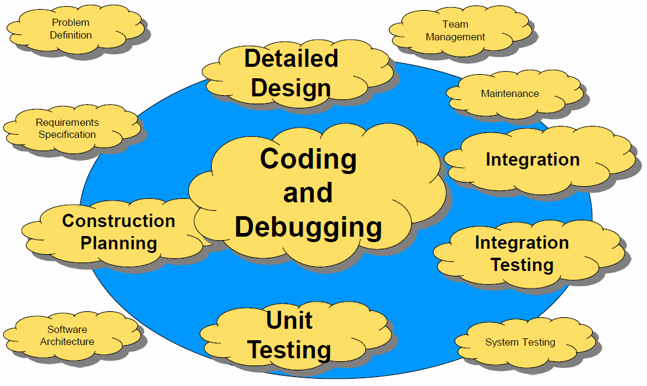

### Warum ist Software Construction so wichtig

* Konstruktion ist ein grosser Teil der Softwareentwicklung
* Konstruktion ist die zentrale Aktivität in der Softwareentwicklung
* Mit einem Fokus auf Konstruktion kann die Produktivität enorm gesteigert werden
* Das Produkt der Konstruktion ist Quellcode, welcher oft das einzig akkurate Produkt einer Software ist

### Qualität als zentraler Faktor

* Reliability: Fähigkeit, fehlerfrei zu funktionieren
* Reusability: Fähigkeit, Komponenten wiederzuverwenden
* Extendibility: Fähigkeit, Änderungen zu tätigen
* Understandability: Fähigkeit, die Software zu verstehen und zu analysieren
* Efficiency: Geschwindigkeit und Kompaktheit der Software
* Usability: Fähigkeit, effizient genutzt zu werden
* Testability: Fähigkeit, Testszenarien zu erstellen und zu testen
* Portability: Fähigkeit, die Software auf anderen Plattformen zu betreiben
* Functionality: Funktionen der Software

### Herausforderungen der Softwareentwicklung

* Reliability (Correctness + Robustness)
  + Es sollte einfacher sein Software zu entwickeln, welche korrekt und ausreichend funktioniert 🡪 Software laufen lassen und teste (So oft wie möglich)
* Reusability (Modifiability + Extendibility)
  + Man sollte weniger Software schreiben müssen und Software sollte einfach zu modifizieren sein 🡪 Software sollte so oft wie möglich neu entwickelt und verbessert werden
* Functionality (Usability)
  + Man sollte sich vergewissern, dass die Software die geforderten Erwartungen erfüllt und diese leicht umsetzt 🡪 Software sollte so früh wie möglich als Prototyp erstellt werden und durch den Benutzer getestet werden

### Ziel der Software Construction

Das Ziel der Software Construction ist es ein Produkt zu entwickeln, welches die geforderten Erwartungen erfüllt. Die Software muss dabei nicht perfekt sein, jedoch alle Anforderungen erfüllen.

### Infrastruktur für eine Softwareverwaltung

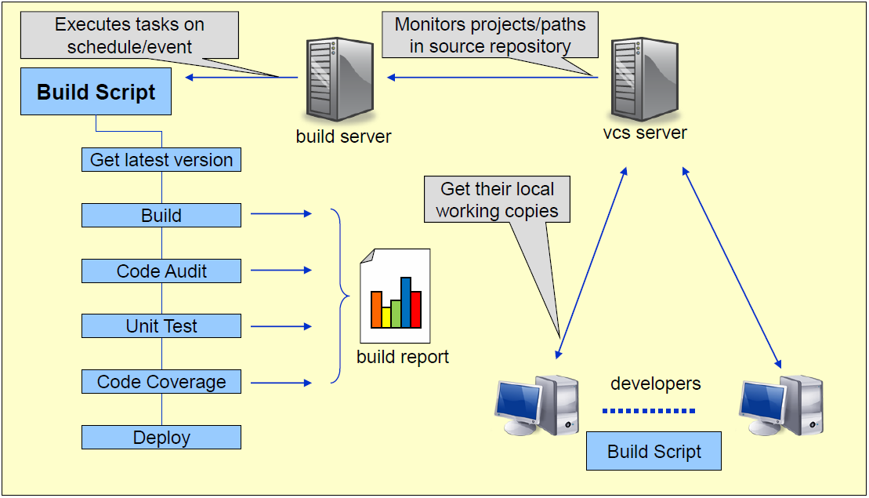

## Versionsmanagement

### Probleme und Herausforderungen

* Mehrere Personen arbeiten am gleichen Projekt und zerstören sich gegenseitig den Code
* Es werden frühere Versionen des Projekts benötigt oder sie müssen sogar nebenbei weiterentwickelt werden
* Man möchten den Verlauf einer Quellcodedatei analysieren
* Code dupliziert sich in mehreren Projekten
* Am Anfang sind nicht alle Anforderungen bekannt

### Definition einer Versionsverwaltung

* Bei einem Versionsmanagement geht es um die Verwaltung ständig ändernder Artefakte (Siehe nachfolgende Auflistung samt Unterscheidung)
* Das Versionsmanagement ist ein Teil des Konfigurationsmanagements zu sehen, welches allgemein für das Erstellen und Aufrechterhalten aller Artefakte verantwortlich ist
* Aufgrund dieser Anforderungen gesellen sich zusätzliche Aktivitäten wie Konfigurationsplanung, Tool-Selektion, Release-Planung und Management, Reporting des Konfigurationsstatus, Change-Request Management, Konfigurationskontrolle, Verantwortlichkeiten und die Konfigurations-Identifikation zum Software Konfigurationsmanagement hinzu
* Für das Versionsmanagement zentral ist jedoch die Verwaltung der Projektartefakte

### Projektobjekte für eine Versionsverwaltung

Konfigurationsobjekte

* Infrastrukturbeschreibung (Build System)
* Quellcodedatei (Produktiver Code, Testing Code, Testdaten)
* Ressourcen (z.B. Übersetzungen, Icons etc.)
* Konfigurationsdatei
* Spezifikationsdokumente
* Designdiagramme
* Projektpläne
* Releasedokumentation
* Installationsanleitungen
* Datenbankmodell/Datenbankscript und Migrationsscript

Keine Konfigurationsobjekte

* Generierte Konfigurationsdatei
* Externe Bibliotheken
* Entwicklungsumgebung und Tools
* Java Framework
* Binaries

Diskutable Konfigurationsobjekte

* IDE Konfigurationen
* Geänderte externe Bibliotheken

## Konzepte des Versions- und Release-Management

### Über Versionen und Releases

Folgende Begriffe sind im Versionsmanagement geläufig:

* Version: Zustand eines Konfigurationselementes mit einem klar definierten Funktionsumfang
* Release: Bezeichnet eine veröffentlichte Version eines Konfigurationselementes
* Variante: Anpassung an eine bestimmte Anforderung oder Organisation

### Typische Release- und Versionsidentifikationen

Für Versionsnummern werden nachfolgende Begriffe verwendet:

* Major: Die Idee ist, das Major-Versionen (mindestens teilweise) inkompatibel sind
* Minor: Änderungen dieser Nummer sind rückwärtskompatibel
* Patch: Bug-Fixes, Änderungen sind vorwärts- und rückwärtskompatibel
* Build: Diese Nummer gibt eine Neukompilierung vom Quellcode an, z.B. aufgrund von Prozessor-, Plattform- oder Compileränderungen.
* Revision: Kleine Änderung an einer Version, welche Fehler behebt, jedoch keinen Einfluss auf den Funktionsumfang haben.
* Variante: Eine Variation einer Version welche entwickelt wurde um z.B. auf einer anderen Hardware oder unter einem anderen Betriebssystem zu laufen. Oder auch um für verschiedene Benutzergruppen feine Anpassungen vorzunehmen. Beispiele: Anpassungen für Tablets, Sehbehinderte, Touchscreens

## Versionskontrollsysteme

### Allgemeine Begriffe und Konzepte

* Repository: Eine Datenbank, in welcher Projektdateien gespeichert werden. Ein Repository vergisst nichts, d.h. es ist nicht möglich eine Datei wirklich zu überschreiben. Vielmehr wird einfach eine neue Version der Datei gespeichert, die alte bleibt weiterhin im Repository und kann auch weiterhin zugegriffen werden
* Working Copy: Eine lokale Kopie aller relevanten Projektdateien. Der Entwickler arbeitet immer auf dieser lokalen Kopie. Es wird also nie direkt auf den Dateien im Repository gearbeitet
* Checkout: Ist die Bezeichnung für den Vorgang, wenn eine Working Copy vom Repository bezogen wird. Dies ist eine reine Leseoperation auf dem Repository. Dabei wird auf der Entwicklermaschine eine neue Working Copy angelegt
* Commit: Bezeichnet den Vorgang, wenn eine Datei oder ein ganzes Set an Dateien (neu oder geändert) mit einer Beschreibung ins Repository gespeichert wird. Man spricht auch davon diese Dateien unter Versionskontrolle zu bringen. Dies ist eine Schreiboperation auf dem Repository die atomar erfolgt, d.h. pro Commit werden entweder alle oder gar keine Dateien im Repository gespeichert. Damit ist sichergestellt, dass das Set an Dateien konsistent ins Repository gespeichert wird. Es ist nicht möglich, dass durch zwei gleichzeitige Commits die Dateien durcheinandergebracht werden
* Update (nur Subversion): Bezeichnet den Vorgang, wenn Dateien aus dem Repository mit der eigenen Working Copy abgeglichen werden. Indem andere Entwickler ihre Arbeit committen erhält das Repository neue Versionen welche auf den Working Copies der anderen Entwickler noch nicht vorhanden sind. Der Abgleich findet auf der Working Copy statt, für das Repository ist ein Updatevorgang somit eine reine Leseoperation
* Revision, Version: Jeder Commit verändert den Inhalt des Repositories und erzeugt somit eine neue Version oder Revision des Repositories die eindeutig identifizierbar sein muss. Dies ist notwendig um später wieder auf einen bestimmten Stand der Arbeit zurückkommen zu können. Manche Repositories verwenden mehrstellige Versionsnummern (z.B. CVS), andere nummerieren die Commits einfach durch (z.B. Subversion) oder vergeben einen Hash (z.B. Git) als Identifikation
* Entwicklungsverlauf (Baseline, Codeline, Line of Development): Dies sind Bezeichnungen für eine Menge von relevanten Projektdateien die zusammengehören und die miteinander weiterentwickelt werden. Eine Working Copy enthält all diese Dateien einmal. Ein Entwicklungsverlauf bezeichnet aber die gesamte Historie dieser Dateien während des Entwicklungsverlaufes. D.h. er enthält alle relevanten Projektdateien in allen Versionen für einen bestimmten Entwicklungsverlauf. Ein Entwicklungsverlauf ist eindeutig über seinen Revisionsverlauf gekennzeichnet. Der Hauptentwicklungsverlauf wird in Subversion oder CVS auch einfach trunk genannt und in Git heisst er üblicherweise master
* Branch: So wird eine Verzweigung von Entwicklungsverläufen genannt. Branches sind selber auch wieder Entwicklungsverläufe. Sie enthalten selber eine eigene, von anderen Entwicklungsverläufen unabhängigen Historie. Je nach Versionsverwaltungssystem werden Branches unterschiedlich eingesetzt
* Merging: Bezeichnet den Vorgang zwei Entwicklungsverläufe zu vereinen. Dazu müssen Dateien in unterschiedlichen Versionen zusammengeführt werden. Dies ist in der Regel ein manueller Vorgang der nur bedingt automatisiert werden kann. Wie beim Branching wird auch das Merging unterschiedlich unterstützt von den verschiedenen Versionskontrollsystemen
* Tag, Label: Identifiziert bzw. markiert eine bestimmte Revision eines Entwicklungsverlaufes oder Configuration Items und fügt ihm noch zusätzliche Informationen hinzu (z.B. gibt ihm einen bestimmten Namen oder Bemerkung wie beispielsweise: „Release für Demo anlässlich Veranstaltung xxx“). Tags sind konzeptionell keine Entwicklungsverläufe, sondern nur eine Momentaufnahme (Snapshot) eines solchen
* Clone: Als Clone bezeichnet man eine lokale Kopie eines Repositories von einem Remote Server
* Push, Pull: Bezeichnet bei verteilten Versionsverwaltungen die Synchronisationen zwischen zwei Repositories. Eine Push-Operation verschiebt den Zustand des lokalen Repositories/Branch auf das Remote-Repository. Eine Pull-Operation holt den neuesten Zustand vom Remote und synchronisiert ihn mit dem lokalen Repository

### Zentralisierte versus Verteilte Kontrollsysteme

Bei einer zentralisierten Versionsverwaltung befinden sich die Repositories auf einem zentralen Server. Der Entwickler holt sich seine Working Copy von diesem zentralen Server und speichert diese auch wieder direkt zurück. Der zentrale Server stellt dabei einen Single Point of Failure dar.



Bei einer verteilten Versionsverwaltung wird hingegen nicht nur die Working Copy, sondern gleich eine komplette Kopie des Repositories lokal gespeichert. Der Entwickler kann somit autark lokal arbeiten und bei Bedarf sein Repository zurückpushen.



# Woche 2

In Woche 2 wurde Git mitsamt Branches und dem Git Workflow erklärt. Dabei lässt sich folgendes über Branches zusammenfassen:

* master: Enthält den produktiven Code
* develop: Enthält den eigentlichen Code in der Entwicklung. Wird eine funktionsfähige oder zu veröffentlichende Version erreicht, wird develop in master zurück gemergt und der master Branch getaggt
* feature: Enthält die jeweiligen zu entwickelnden Features

Die feature Branches werden dabei immer lokal erstellt und in der Regel nicht gepusht.

# Woche 3

In Woche 3 wurden die aus Woche 2 gelernten Techniken in die Praxis umgesetzt. Unsere Gruppe hat das Repository mrs-group10 erstellt und alle wichtigen Branches erstellt.

# Woche 4

## Automation

### History

* Since the early days of modern engineering, automation of build process has been the key to:
  + Productivity improvements
  + Quality insurance
  + Eliminate dependencies on key personnel
  + Save time and money
* Software development is not different

### Description

* Build the component at the push of a button!”
  + Always more to it than just “configure” & “make”
  + ssh to right host; svn checkout; untar; setenv, etc.
  + The button can be pushed automatically

### Why should we care

* Common Problems
  + Developers can’t reliably build applications locally
  + Lack of consistent versioning
  + Unit testing is not consistent
  + State of the build is unknown
  + Dependencies between components are unknown
  + Deployment is not transparent
  + Manual work is error prone
  + Repeating work is boring
  + Automation is documentation
  + Confidence

### Build Automation Procedures

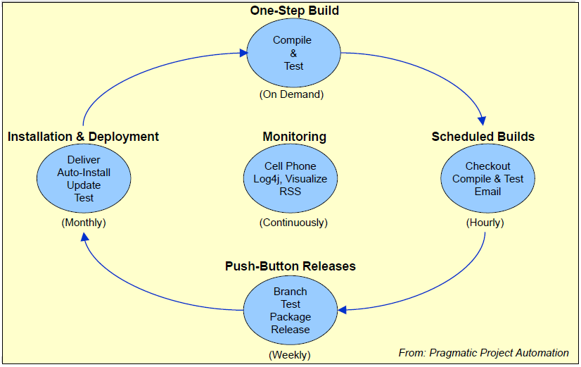

### Automation Prerequisites

* Build server
* Source code control server
* Well outlined process
* Tools
* Developer responsibilities
  + Code checked in before end of day (at least!)
  + Code must be buildable
  + Code must have and pass unit tests

### CRISP Builds

* Complete: Recipe lists all ingredients
* Repeatable: Version control time machine
* Informative: Radiate valuable information
* Schedulable: Complete and repeatable
* Portable: Machine-independent Software

## Build tools

Two main categories

* Scripting tools
  + Ant
  + Rake (Ruby based)
  + Gradle (Groovy based)
* Artifact oriented tools
  + Maven
  + Debian Package Creation

## Maven

### What is Maven

* A build tool
* A dependency management tool
* A documentation tool

### Maven Core Concepts

* Based on a declarative instead of imperative configuration
  + XML configuration file
* Follows Convention over Configuration
  + E.g. use suggested directory structure

### What Maven does

* Builds the project (Compile, generate sources etc.)
* Launch tests and gathers results
* Packages the artifacts
* Documents and generates reports
* Controls quality of your code
* Software
* Flow
  + Checkout
  + Resolve dependencies
  + Check the code
  + Compile the code
  + Copy the resources
  + Copy the configuration
  + Execute the unit tests
  + Generate the documentation
  + Create the installation package
  + Deploy the package

### The Project Object Model (POM)

Contains all Information about your project

* Basic project information
  + URL, developers, groupId, artifactId, version, developers, license, …
* Build section
  + Customization of the build process
  + Build plugins
* Reporting section
* Dependency configuration



### POM Sample



Mandatory

* groupId: the organization identifier such as the DNS name
* artifactId: the name of the product
* version: the release identifier

Optional

* packaging: the type of the package (jar, war, ear, …)
* name: the project name
* url: the project’s web page

### Dependency Management

Artifacts are automatically downloaded from the central maven repository and stored in the local repository

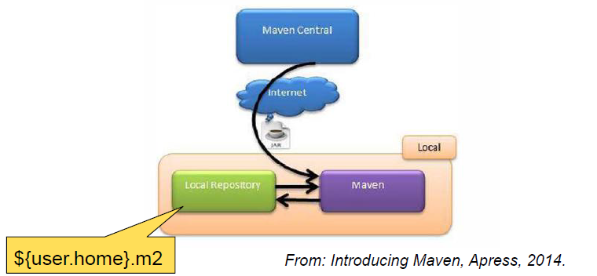

### Local Repository

* A local cache for artifacts
* Contains temporary build artifacts
* You can erase it regularly
* Very useful for offline builds
* By default, in user home’s .me/repository folder
* Can be moved to any other place through maven runtime settings.xml

### Life Cycle, Phases and Goals

Maven provides several standard build processes (Life Cycles).

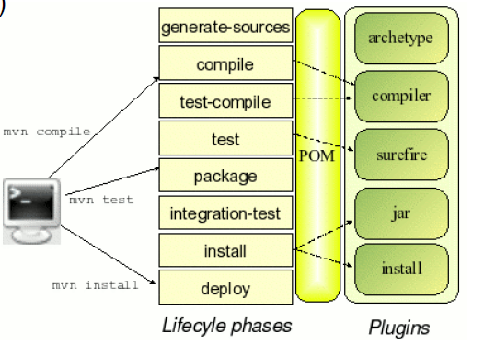

When you invoke a phase “mvn package”, Maven will go through all phases until the one specified, executing all the bound goals. By default, all the basic necessary plug-ins for the build phase are already bound to phases

### Default Life Cycle

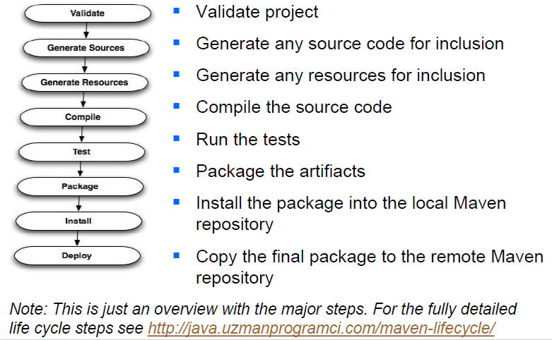

### Plugins

* A plug-in is made of a MOJO (Maven POJO), which is simply a java class which adds new functionality to Maven
* A plug-in can define goals and reports
* Goals can be called directly: mvn pluginname:goalname
* Goals can be bound to one or multiple phases
* Reports are used during site generation: mvn site



### Properties

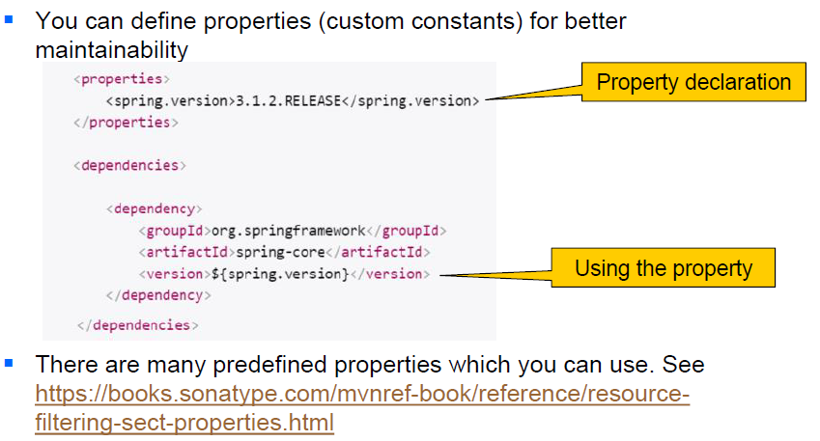

## Drawbacks of Maven

* Library repositories are not always safe
* Maven conventions
  + You have to stick with them
* Sometimes hard to find information about some things about maven and plugins
  + Often copy-and-paste
* A huge output log
* Learning Maven is long in comparison to other tools (like ant, for example)

## Maven Best Practices

* Embrace the standardization of Maven, don’t fight it
* Keep your builds as simple as possible
* Launch your builds regularly

# Woche 5

In Woche 6 fand aufgrund der Osterferien keine Schule statt.

# Woche 6

In Woche 6 fand aufgrund der Osterferien keine Schule statt.

# Woche 7

## Continuous Integration

### Integration

* Modularization
  + Enables team development
  + Makes complex systems manageable
* Modules have to work together
  + i.e. they must be integrated
* Integrated Modules do successfully
  + Compile
  + Run
  + Pass tests
  + Deploy

### Integration Challenges

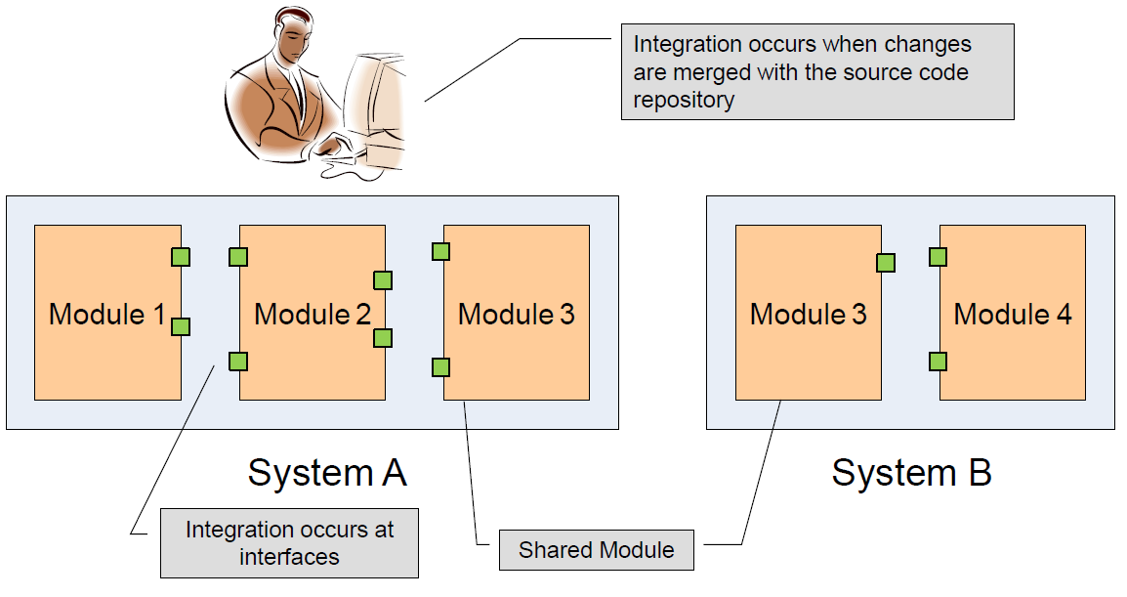

### Broken Integration

* You have a broken integration when:
  + Integration server does not build successfully
  + Shared component works in one system, but breaks others
  + Unit tests fail
  + Code quality fails (coding conventions, quality metrics)
  + Deployment fails
* The earlier you can detect problems, the easier it is to resolve them

### Manual Integration

* Integration becomes expensive
  + If made manual (build, test, deployment etc.)
  + With too less checking’s (hours or days etc.
  + If integration problems and bugs are detected too late
* Reduces desire to refactor
  + Long time between integration increases risk of merge
* IDE makes many cross-cutting changes easy

### Definitions of Continuous Integration

* “An important part of any software development process is getting reliable builds of the software. Despite its importance, we are often surprised when this isn't done. We stress a fully automated and reproducible build, including testing, that runs many times a day. This allows each developer to integrate daily thus reducing integration problems.” - Martin Fowler and Matthew Foemmel, Continuous Integration
* “The macro process of object-oriented development is one of "continuous integration." ... At regular intervals, the process of "continuous integration" yields executable releases that grow in functionality at every release. ... It is through these milestones that management can measure progress and quality, and hence anticipate, identify, and then actively attach risks on an ongoing basis.” - Grady Booch, Object-Oriented Analysis and Design with Applications

### Practices of Continuous Integration

* Maintain a single source repository.
* Automate the build
* Make your build self-testing
* Everyone commits every day (at least!)
* Every commit should build the mainline on an integration machine
* Keep the build fast
* Test in a clone of the production environment
* Make it easy for anyone to get the latest executable
* Everyone can see what's happening
* Automate deployment

### Embrace Continuous Integration

* What is Continuous Integration
* Integration server monitors source repository
  + Rebuilds with every change
  + Runs all unit and acceptance tests
  + Publishes build results
  + Notifies developers if build breaks
  + Labels successful builds in source repository

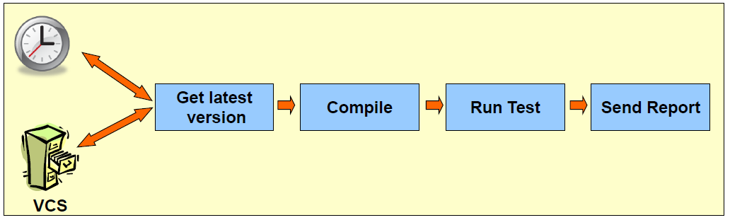

### Continuous Integration Prerequisites

* Tools needed
  + VCS server
  + Build server
  + Deployment Server
  + Automation tools
  + CI tools
* Work Process
  + Commit/Update often (each change)
  + Run often
  + Write test
  + Run test often
  + Common code ownership

### Continuous Integration Infrastructure

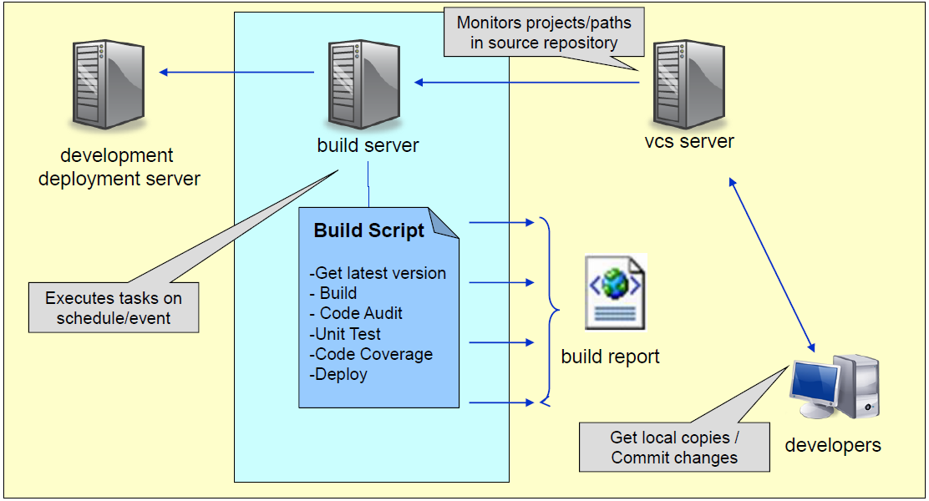

### Realizing Continuous Integration

* Monitors a VCS repository for changes
  + SVN 🡪 check for commits in the repository since last build time
  + If changes are found, then (or on schedule) start the build
* Build your application
  + By running your existing Ant or Maven scripts
* Run your xUnit Test suite
* Run code audit tools
  + Checkstyle, code coverage etc.
* Report on the build results
  + Send (formatted) email notifications
  + Publish results to a website
* Publish the application (Optionally)

### What is a successful Build?

* Of Course:
  + When it compiles
  + When all the unit-tests have run?
  + When it has been deployed successfully?
* But also:
  + When the build fails
  + You have exposed a potential problem –early!

## The Agile Process

### Overview

* Continuous Integration is only one aspect of an overall efficient development process. For it to work best, you need to:
* Plan iteratively
  + Schedule regular releases with evolving levels of functionality
  + Beware of inflexible Change Control Boards
* Implement incrementally
  + Identify and implement small work tasks
  + Refactor continuously!
* Report proactively
  + Identify exactly the content and output (CI) of any build
  + Automate reporting!

### Continuous Integration Benefits

* General: Reduced risks
* Always be aware of current status of the project
* Less time spent investigating integration bugs
* Integration testing performed early
* Integration bugs caught early
* Less time wasted because of broken code in version control system
* Broken builds caught early
* Prove your system can build!
* Increase code quality with additional tasks
* Discover potential deployment issues

### Continuous Integration Obstacles

* Tough to move an existing system into CI
* Systems that rely on “server” components (BizTalk, SharePoint, etc.)
* Db-based systems need to be up-to-date

## Jenkins as Continuous Integration Tool

### Overview



### Features

* Continuous Integration Server
* Combines building, unit tests, code coverage, analysis etc.
* Provides the ability to hook in almost any output
* Gives instant knowledge of status of builds
* Provides dashboard like integration for multiple projects

### Components

* CI Server
  + Monitors the VCS
  + Executes the build script
* Management Console
* Dashboard
  + Build report viewer
* Email Notification

### Add-Ons

* Many built in Plug-ins
  + Test Code Coverage
  + Analysis
  + Unit testing
  + Doxygen
  + Ant
  + Google Calendar
  + Dependency Management with IVY, Maven

### Other Continuous Integration Tools

* Bamboo: https://www.atlassian.com/software/bamboo
* Cruise Control (OS): http://cruisecontrol.sourceforge.net/
* Anthill Pro (Com): http://www.anthillpro.com/
* Continuum (OS): http://maven.apache.org/continuum/
* Pulse (Com): http://www.zutubi.com/
* Luntbuild(OS): http://luntbuild.javaforge.com/
* ParaBuildServer (Com): http://www.viewtier.com/index.htm
* TeamCity: http://www.jetbrains.com/teamcity/
* Tools Overview: http://confluence.public.thoughtworks.org/display/CC/CI+Feature+Matrix

## Summary

* Continually integrate and test to reduce risk
* Detect problems early
* Always have a deployable build
* Generate metrics to guide project management
* Continuous Integration is: Vital for successful software development

# Woche 8

## Why should I care about Coding Style?

* 80% of the lifetime cost of a piece of software goes to maintenance
* Code is written once, but read all other times
* Hardly any software is maintained for its whole life by the original author
* Clean code improves the readability of the software, allowing engineers to understand new code more quickly and thoroughly

## The cost of a mess



## Definition of clean code

Clean code is simple and direct. Clean code reads like well-written prose. Clean code never obscures the designer’s intent but rather is full of crisp abstractions and straightforward lines of control.

## Code Rules

### Meaningful Names

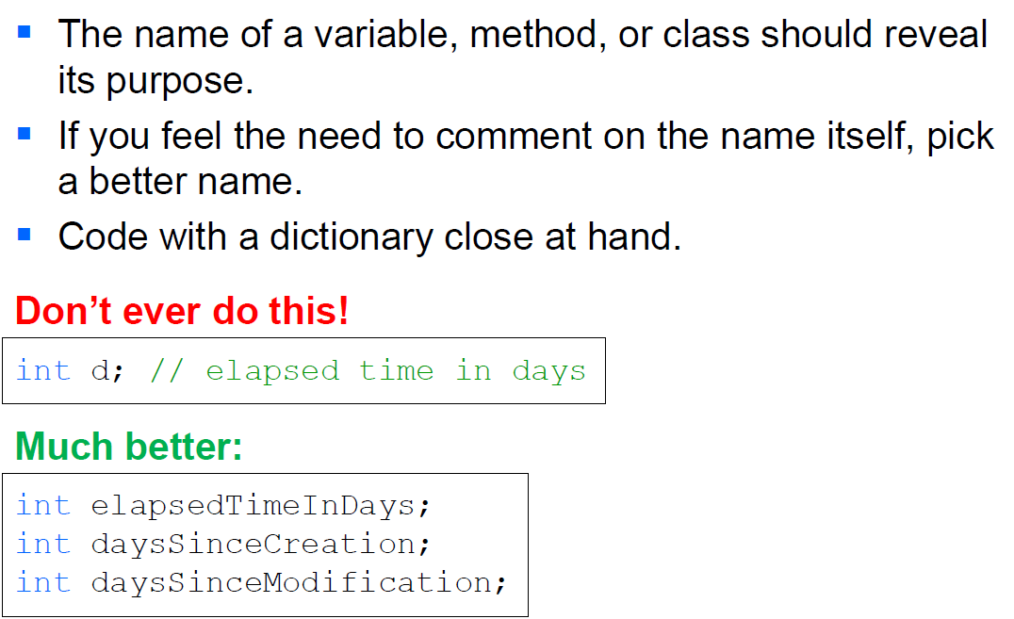

### Clean Formatting

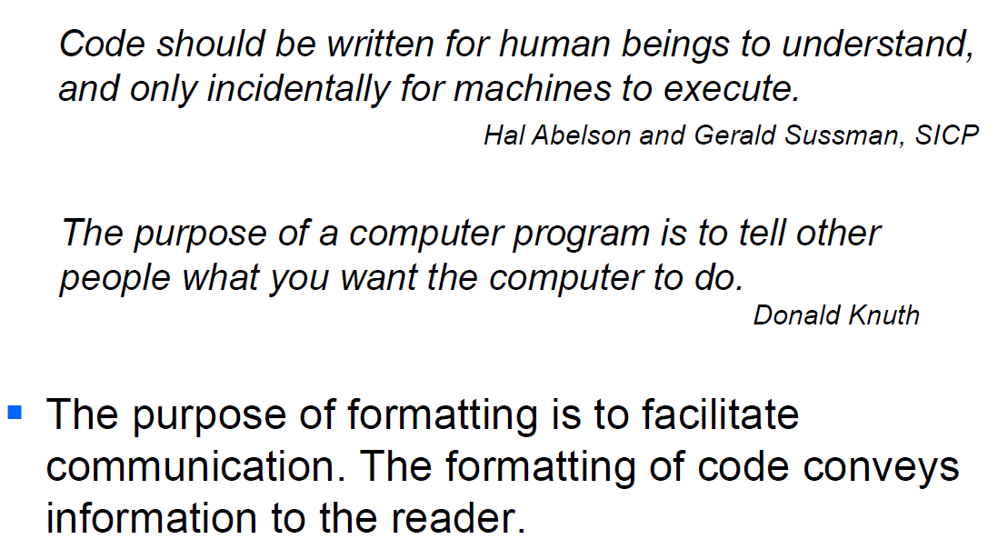

### Vertical Formatting

* Newspaper metaphor
* Vertical density
* Vertical distance
* Vertical ordering

### Vertical openness between concepts

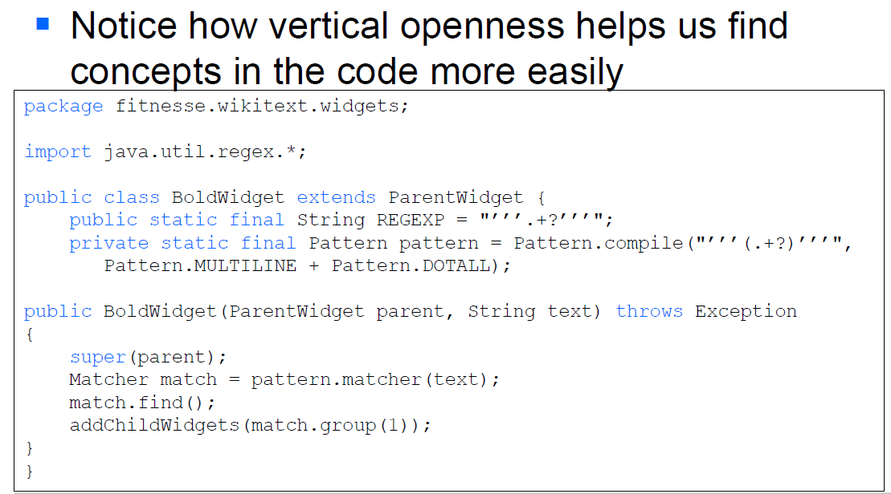

### Vertical Density

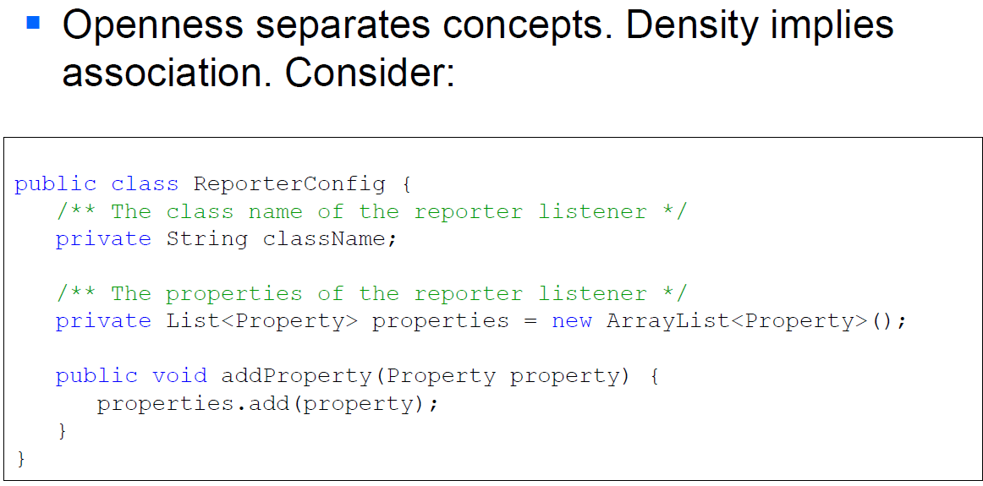

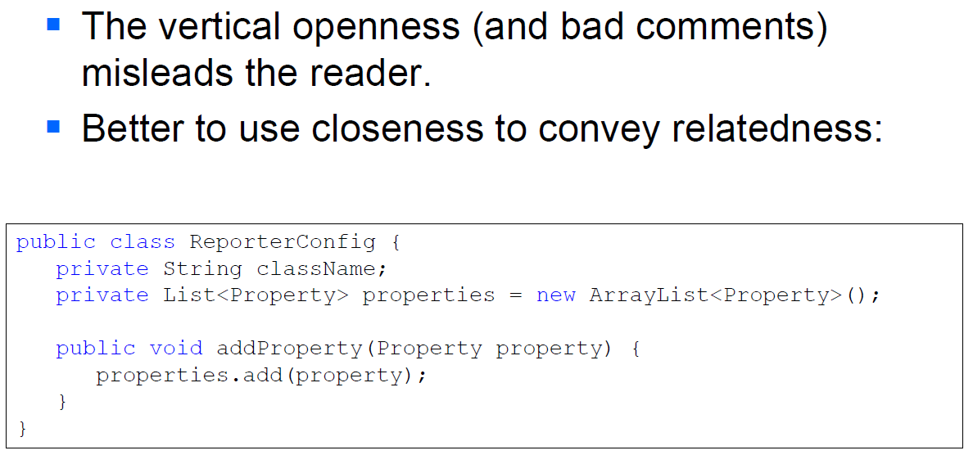

### Vertical Distance and Ordering

Concepts that are closely related should be vertically close to each other:

* Variables should be declared as close to their usage as possible
* Instance variables should be declared at the top of the class
* Dependent functions: callers should be above callees

### Horizontal Openness and Density

* Keep lines short:
  + Better 80 characters than more
* Don’t try to horizontally align lists of assignments
  + It draws attention to the wrong thing and can be misleading, e.g., encouraging the reader to read down a column
* Always indent scopes (classes, methods, blocks)

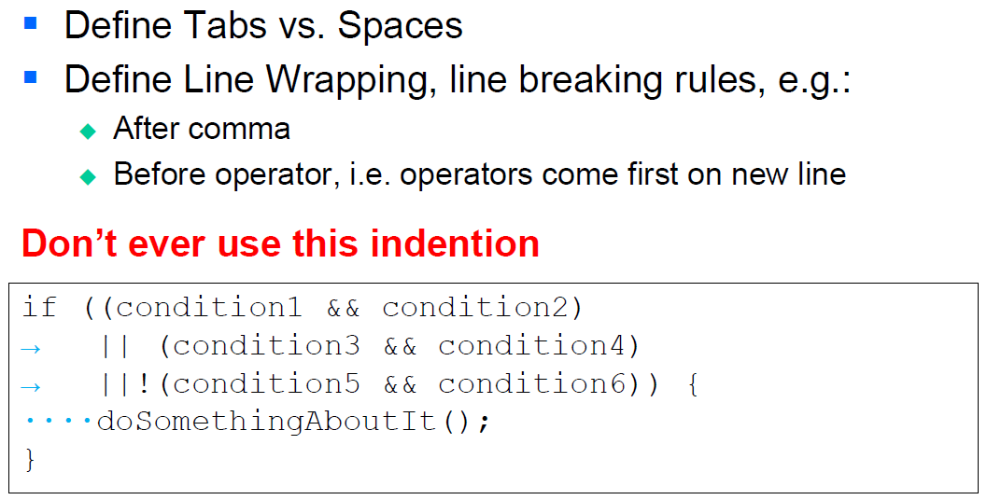

* Define clear spacing rules, e.g.:
  + Put spaces around = to accentuate the distinction between the LHS and RHS
  + Don’t put spaces between method names and parents, or parents and parameter lists -they’re closely related, so should be close
  + Use spaces to accentuate operator precedence, e.g., no space between unary operators and their operands, space between binary operators and their operands

### Team Rules

* Every team should agree on a coding standard
* Beware of code formatting standards getting religious.
* If the language you are using has a code convention (like Java’s), use it!
  + Oracle (outdated in 1999 and plain wrong C-examples): http://www.oracle.com/technetwork/java/codeconv-138413.html
  + Google (better, up to date): http://google-styleguide.googlecode.com/svn/trunk/javaguide.html
  + Microsoft (C#): http://msdn.microsoft.com/en-us/library/ff926074.aspx

## Code Checking

### Apply and Check Code Conventions

* Code conventions usually cover:
  + Filenames, file organization
  + Formatting like indentation, white spaces, line breaks
  + Naming conventions
  + Declarations, statements
  + Comments
  + And of course: programming practices

### Check Code with Checkstyle

* Does code checking based on a set of (configurable) rules
* Available as command line version and plugin for various IDEs
* http://checkstyle.sourceforge.net/(commandline)
* http://eclipse-cs.sourceforge.net/(Eclipseplug-in)
* Uses an XML-configuration file
* Rules consist of a (recursive) set of modules.
* Extensible by writing your own checks

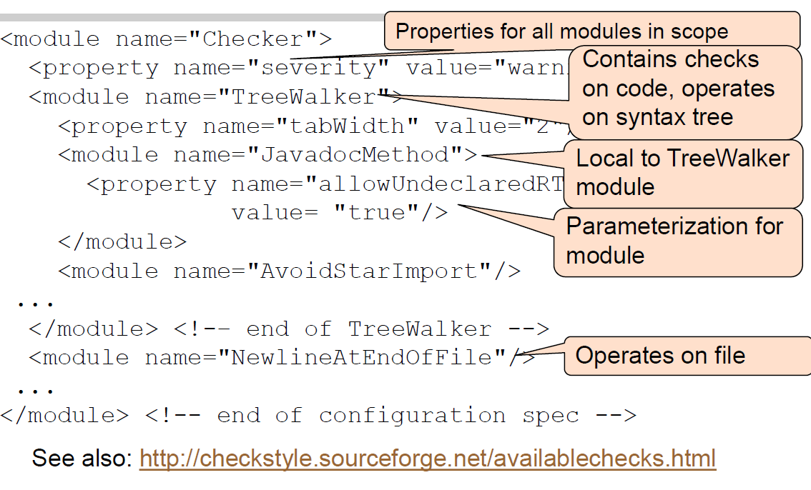

## Code Documentation

### Clean Documentation

* Program documentation is for programmers, not end users
* There are two groups of programmers, and they need different kinds of documentation
  + Some programmers need to use your code
    - Do not explain to them how your code works--they don’t care and don’t want to know
    - They are interested in the interfaces not in your code!
    - Tell them what your methods do, how to call them, and what they return
    - Use an API documentation tool
  + Other programmers need to maintain and enhance your code
    - They need to know how your code works
    - They will read and understand your code
    - Use internal comments for these programmers
* When you work on your program, you are in both groups
  + Document as though you will have forgotten everything by tomorrow!

### API Documentation is a contract

* API documentation is a contract between you and the clients of your code. It specifies…
  + The purpose of the class / interface
  + The functionality of the methods
* Do not be overly generous!
  + Provide what is really needed, but...
  + Remember that anything you provide, you are stuck with debugging, maintaining, and updating

### Class and Interface Documentation

* Specifies the purpose and responsibility of the class/interface
  + Try to provide a one sentence summary
* Specifies important properties that cannot be expressed with the programming language (e.g. immutability, cloneability, singleton)
* Class:
  + Explain properties of algorithms used (performance, memory consumption, persistence etc.)
* Interface:
  + Explain what is done, not how it shall be done

### Method Documentation

* Specifies what you expect from the caller (preconditions & parameters)
* Specifies what you promise to give the caller in return (Post conditions, invariants & return values)
* A precondition is something that must be true beforehand in order to use your method
  + Example: The piece must be moveable
* A post condition is something that your method makes true
  + Example: The piece is not against an edge
* An invariant is something that must always be true about an object
  + Example: The piece is in a valid row and column

### When to write API documentation

* Write the comments before you write the code
  + It’s more effective to decide what to do, then do it than to do something, and then try to figure out what you did
* There is always time at the start of a project
* There is never time at the end of a project

### Rules for Writing Summaries

* For methods, omit the subject and write in the third-person narrative form
* Good: Finds the first blank in the string
* Not as good: Find the first blank in the string
* Bad: This method finds the first blank in the string
* Worse: Method findBlank(String s) finds the first blank in the string

### Clean (Internal comments)

Comments are (often) evil.

* Most comments are compensation for failures to express ideas in code
* Comments become baggage when chunks of code move
* Comments become stale when code changes
* Result: comments lie

Comments don’t make up for bad code. If you feel the need for a comment to explain some code, put effort into improving the code, not authoring comments for it.

* Use internal comments to:
  + Explain what the next section of code does
    - Better: Make it a method with a self-explanatory name
  + Explain complex or confusing code
    - Better: Rewrite the code
    - If it’s complex or confusing, it’s probably buggy as well
* Never repeat the code!
  + count = count + 1; // add one to count
* Use internal comments:
  + If you really can’t make the code simple and obvious
  + To mark places in the code that need work
  + Eclipse, e.g., provides three tags for this purpose (you can add more):
    - TODO--this code still needs to be written
    - FIXME--this code has bugs
    - XXX--I need to think about this some more
    - To see these, choose Window --> Show View --> Tasks
* To temporarily comment code (Eclipse: control-/)
* IMPORTANT: All documentation mirrors the code 🡪 Build Documentation In, Don't Bolt It On

## Javadoc

### Overview

* Is a separate program that comes with the JDK
* Reads your program, makes lists of all the classes, interfaces, methods, and variables, and creates HTML pages displaying its results
* Its output is very professional looking
  + http://java.sun.com/javase/7/docs/api/index.html
  + This makes you look good and it also helps keep your manager from imposing bizarre documentation standards
* Write comments for the programmer who uses your classes
  + Anything you want to make available outside the class should be documented
  + It is a good idea to describe, for your own use, private elements as well
* Javadoc can be set to generate documentation for:
  + only public elements
  + public and protected elements
  + public, protected, and package elements
  + everything--that is, public, protected, package, and private elements

### Tags

* Use the standard ordering for Javadoc tags
  + In method descriptions, use:
    - @param p A description of parameter p.
    - @return A description of the value returned (unless the method returns void).
    - @exception e Describe any thrown exception.
    - @see Adds a "See Also" heading with a link or text entry that points to reference
  + In class and interface descriptions, you may use:
    - @author your name
    - @version a version number or date
* Do not use those tags unless you maintain them!
* <http://java.sun.com/javase/7/docs/technotes/tools/windows/javadoc.html#javadoctags>

### Comments

* Javadoc comments must be immediately before:
  + A package (only in package-info.java)
  + A class
  + An interface
  + A constructor
  + A method
  + A field
* Anywhere else, Javadoc comments will be ignored!

### Hints

* Keep comments up to date
* Use the word “this” rather than “the” when referring to instances of the current class
  + Hence, this object has an especially clear meaning in comments
  + Example: Decides which direction this frog should move. (As a comment in the Frog class)
* Summarize the essence of your method, field or package comment in the first sentence
* Javadoc copies the first sentence into a summary paragraph
* Include examples if they are helpful

## Clean Coding

### General

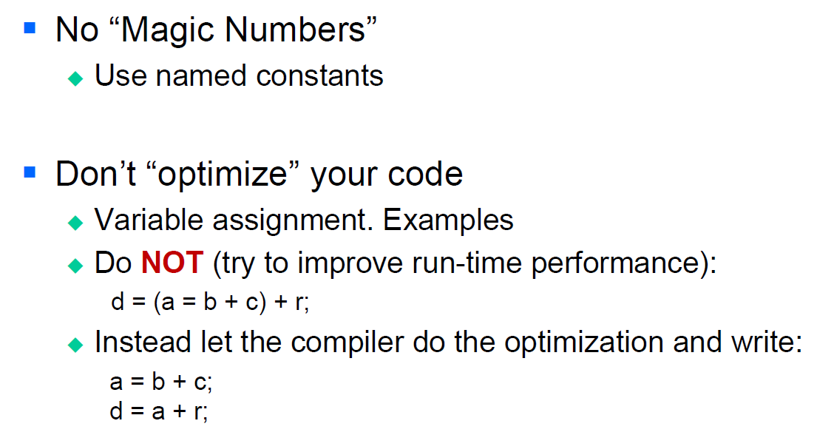

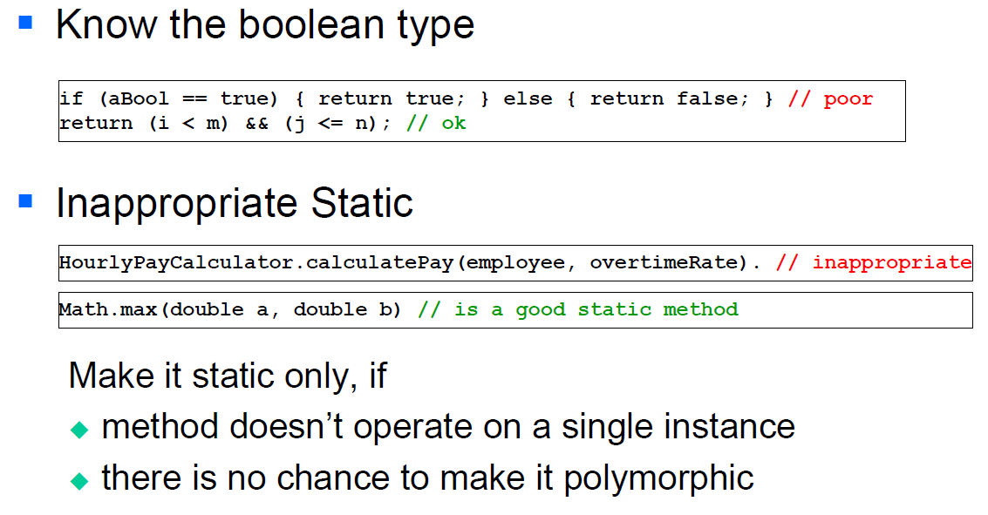

### Writing Functions

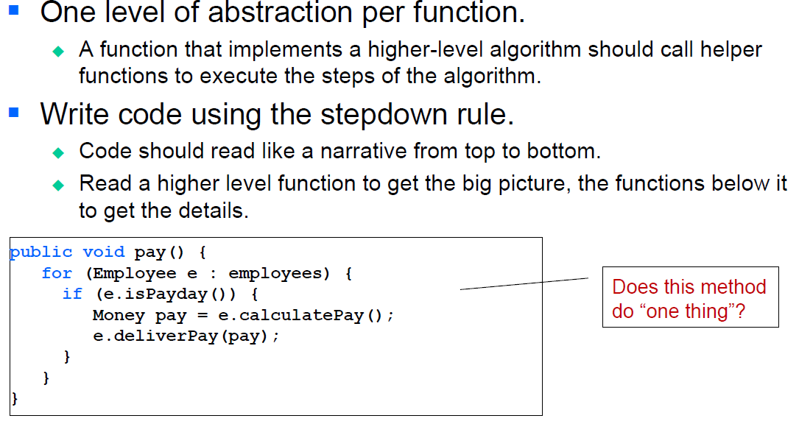

### Negative Conditionals

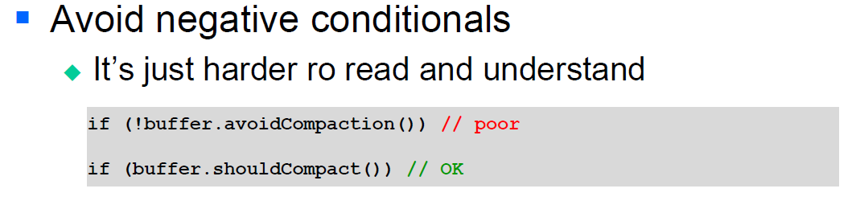

### Arguments

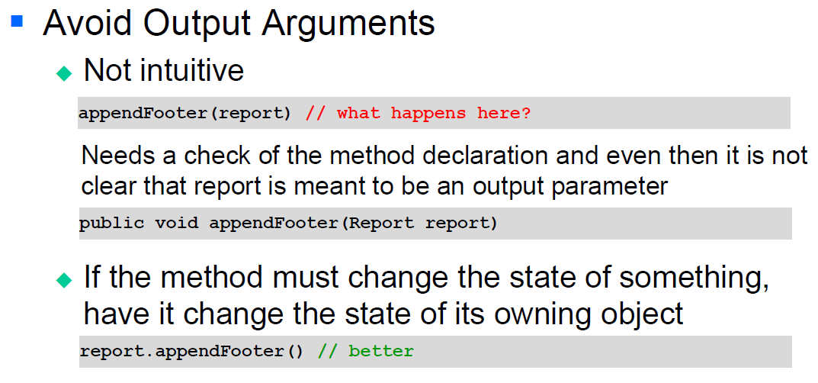

# Woche 9

## Software Problems

### Famous Software Failures

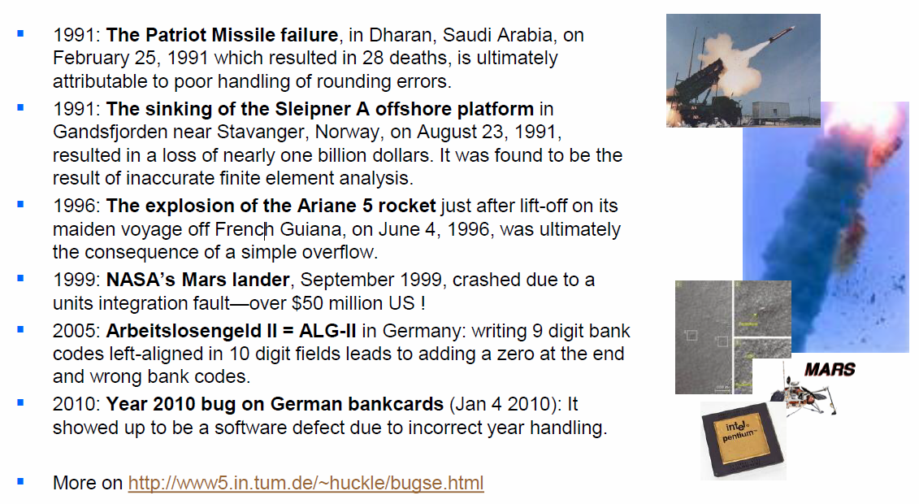

## Software Testing and Failures

### Why does testing matter?

* NIST report, “The Economic Impacts of Inadequate Infrastructure for Software Testing” (2002)
  + Inadequate software testing costs the US alone between $22 and $59 billion annually
  + Better approaches could cut this amount in half
* Major failures: Ariane5 explosion, Mars Polar Lander, Intel’s Pentium FDIV bug
* Insufficient testing of safety-critical software can cost lives:
  + Patriot Missile Failure

In other words: You have to show, that your software does what it is expected to do – correctly!

### Terms

* Validation: The process of evaluating software at the end of software development to ensure compliance with intended usage
  + Did you build the right thing?
* Verification: The process of determining whether the products of a given phase of the software development process fulfill the requirements established during the previous phase
  + Did you build it right?

### What is a Defect?

* An erroneous implementation in the code that causes wrong behavior; a static defect in the software.
* Important: Testing can only show the presence of a defect but not the absence of defects!

### Fault, Errors, Failure

* Software Fault: A static defect in the software = the actual "mistake" or "bug" in the code
* Software Error: An incorrect internal state that is the manifestation of some fault (infection)
* Software Failure: External, incorrect behavior with respect to the requirements or other description of the expected behavior

### From Defect to Failure

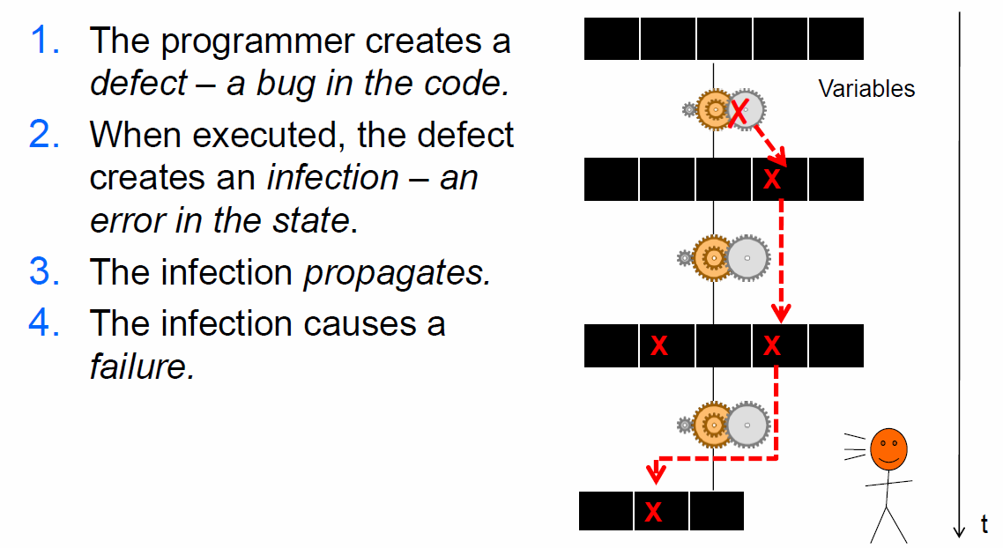

### So what is Testing?

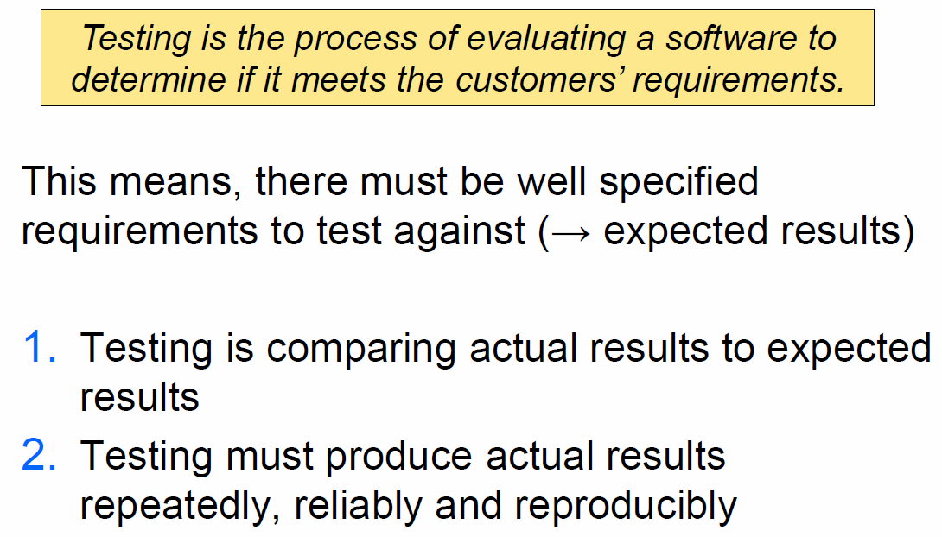

### Regression Testing

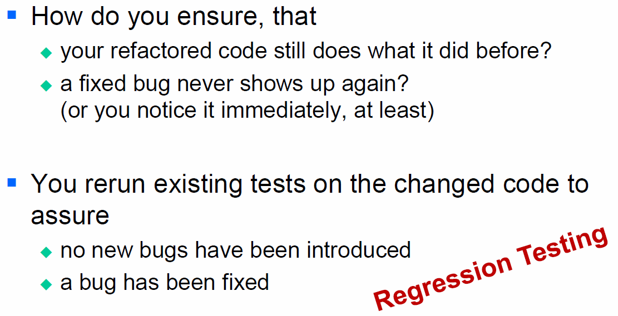

### The Testing Process

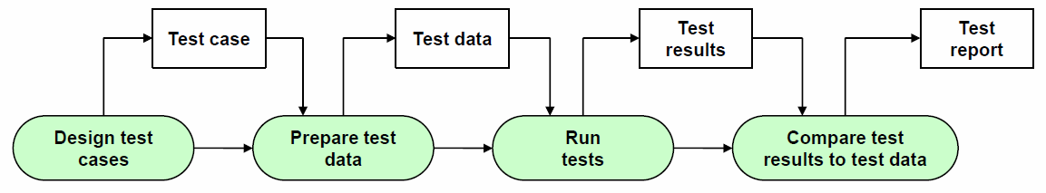

### Unit Testing

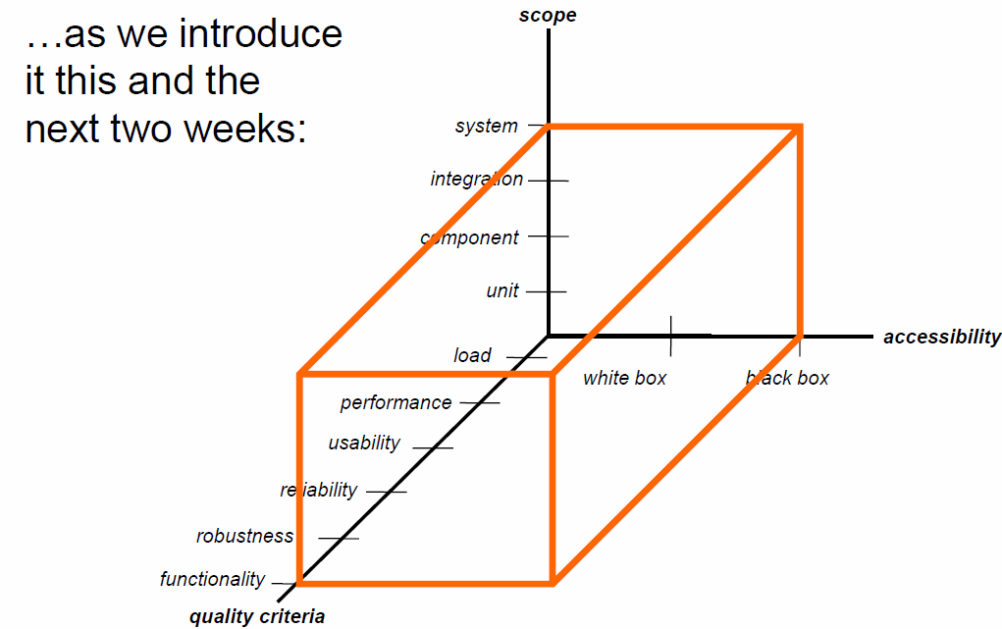

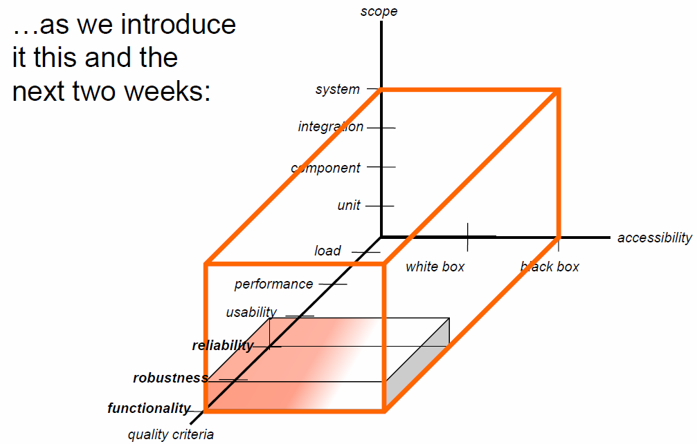

Unit Testing is done

* On each unit (usually class, sometimes method)
* In isolation
* To verify the unit’s behavior

Unit test will

* Establish an artificial environment (called test harness)
* Invoke routines in the unit under test
* Check the results against expected values

## Unit Testing

### Unit Testing Frameworks

* Provides following capabilities:
  + Test specification
  + Test implementation
  + Standard way to specify setup and cleanup
  + Method for selecting individual tests or all available tests
  + Means of analyzing output for expected (or unexpected) results
  + Standardized form of failure reporting
* Use JUnit for Java Unit Testing

### JUnit

* A test class is responsible for testing a unit:
  + Therefore, usually one test class is responsible for testing a single class
  + A test class is a normal Java class. It can have fields, methods, constructors, inner classes etc.
  + If the test class is declared in the same package as the class under test, then it can access its default and protected methods!
  + Usually a class that tests another class X as class XTest {}
* A unit test class consists of several test methods:
  + Test methods take no arguments and return nothing, i.e. a test method is void
  + Each test method should be completely independent of any other test method
  + Often each test method tests a single method of the class under test. IDEs such as Eclipse support this pattern
  + A test method must be public and is marked with the @Test annotation
  + Usually a test method testing a method Y is declared as method testY(){}
* In order to prepare each test, a setup method is called before each test method:
  + In the setup method the test harness is initialized
  + The existence of a setup method guarantees, that each test method starts with exactly the same environment
  + A setup method must be public and is marked with the @Before annotation
  + Usually the setup method is declared as setup(){}
* After each test method, a tear down method is called:
  + The tear down method allows to tidy up the “mess” that was produced during the test method
  + The existence of teardown methods guarantees that the outcome of each test method can be cleaned up
  + A teardown method must be public an is marked with the @After annotation
  + Usually the teardown method is declared as teardown(){}

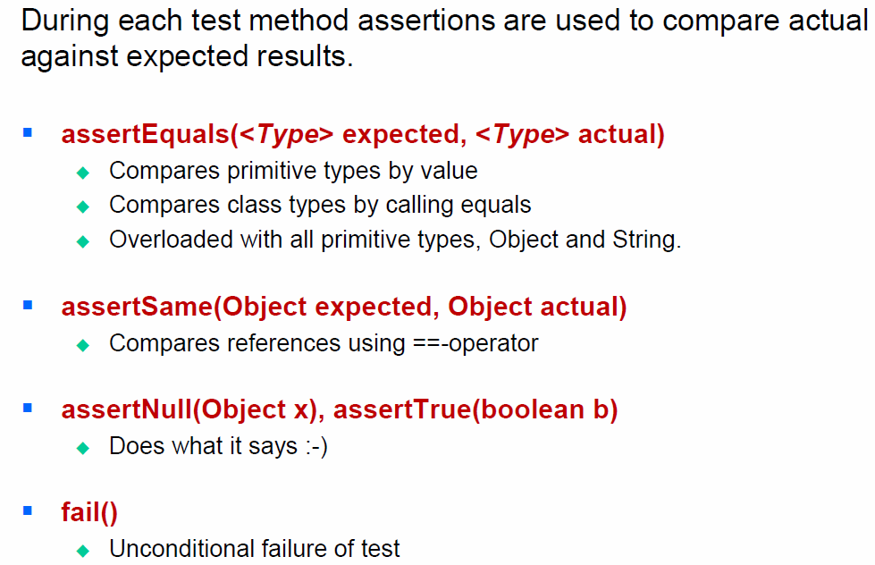

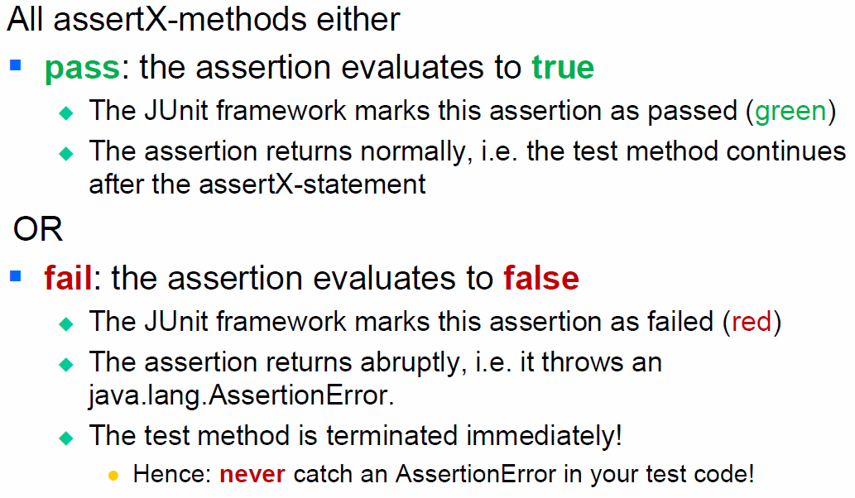

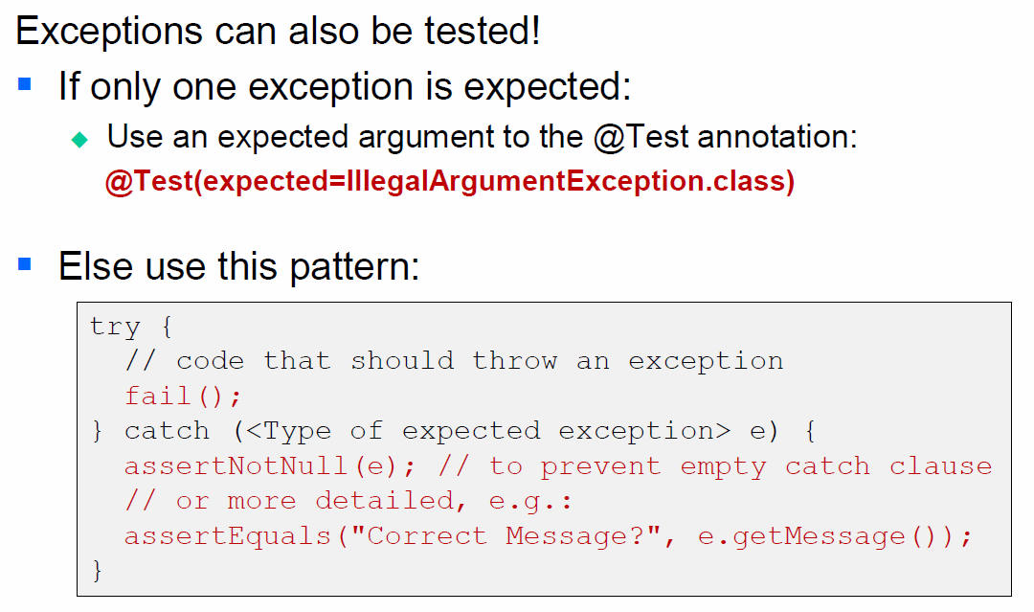

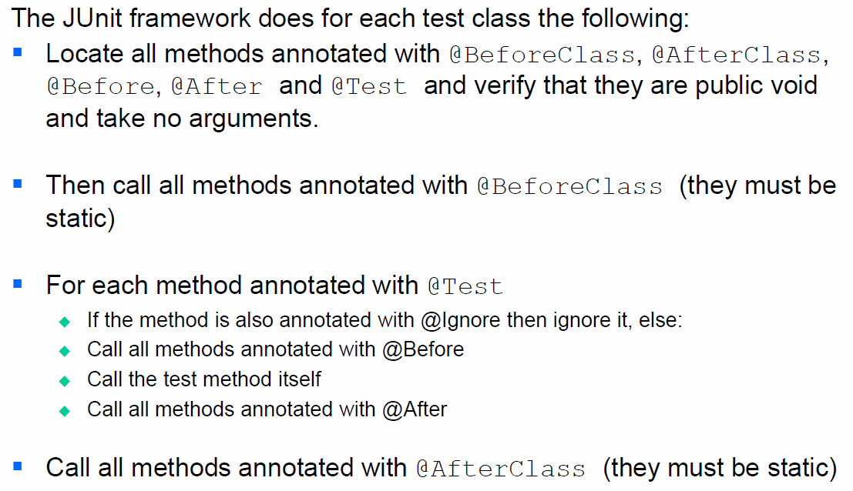

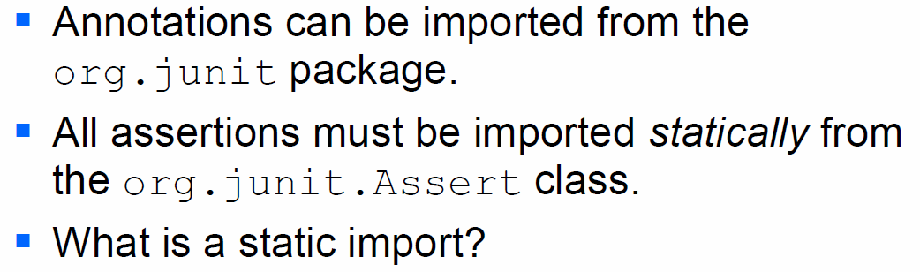

### Organizing Tests

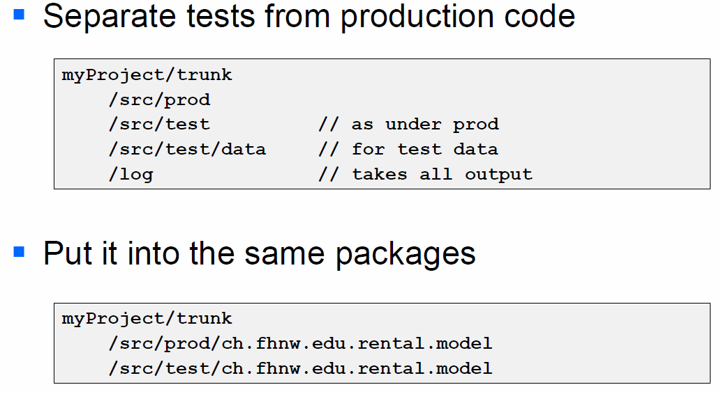

### Bad Excuses

* It takes too much time to write the tests
* It takes too long to run the tests
* It's not my job to test my code
* I don't really know how the code is supposed to behave so I can't test it
* But it compiles
* I'm being paid to write code, not to write tests
* I feel guilty about putting testers and QA staff out of work
* My company won't let me run unit tests on the live system

Nice statement: There does not appear to be a specific set of functional tests exclusively for Java monitors, nor is one necessary. Java Monitors are so widely used by even the simplest of Java programs that almost any functional breakage in Java monitors should be obvious.

# Woche 10

## Good tests

### Good Tests

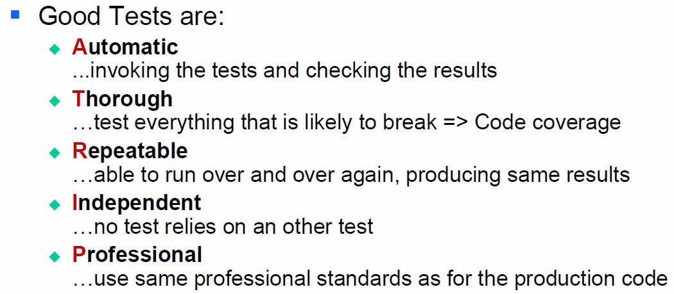

### What to tests?

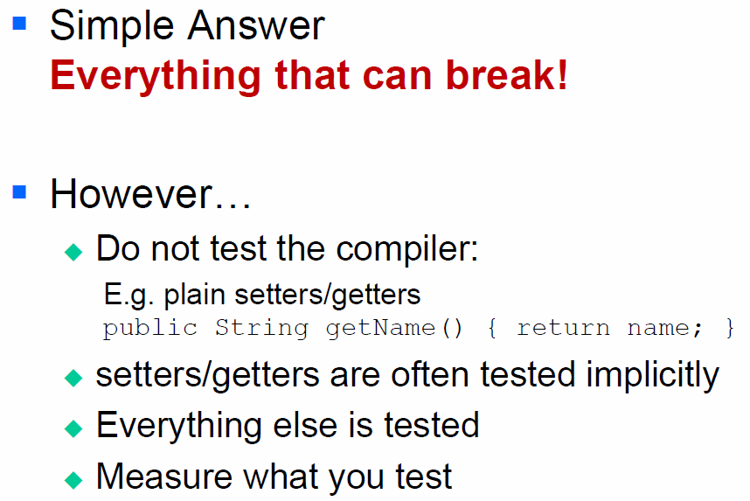

### How much to test?

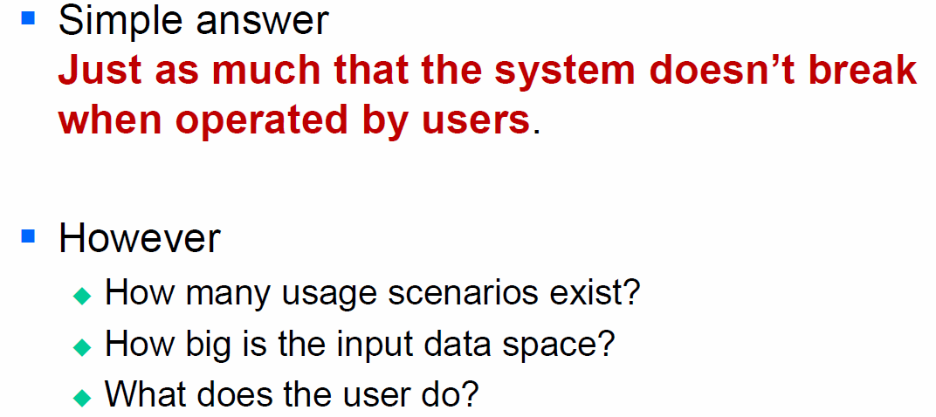

### How much to test – the challenge

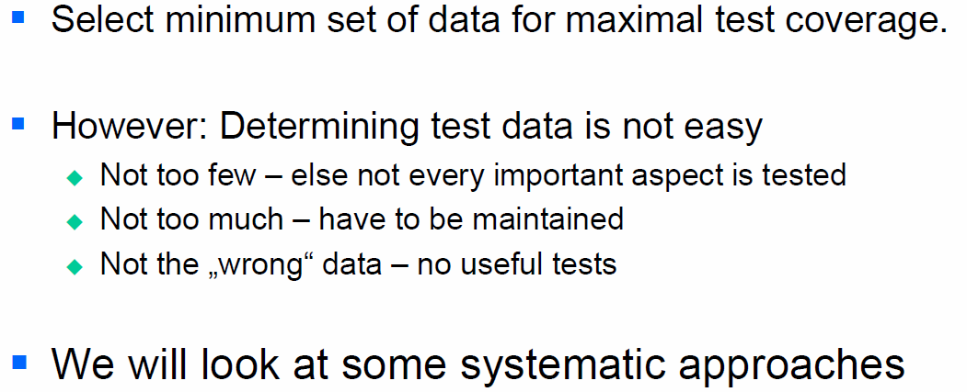

## Testing Techniques

### Determining Test Data

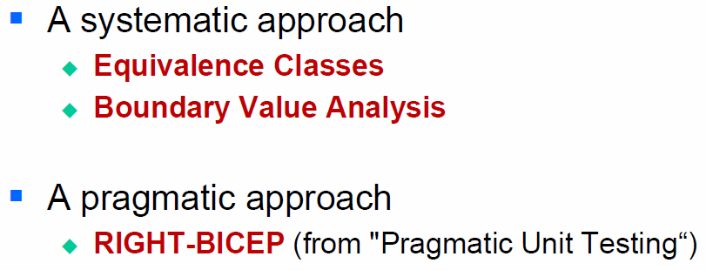

### Equivalence Classes

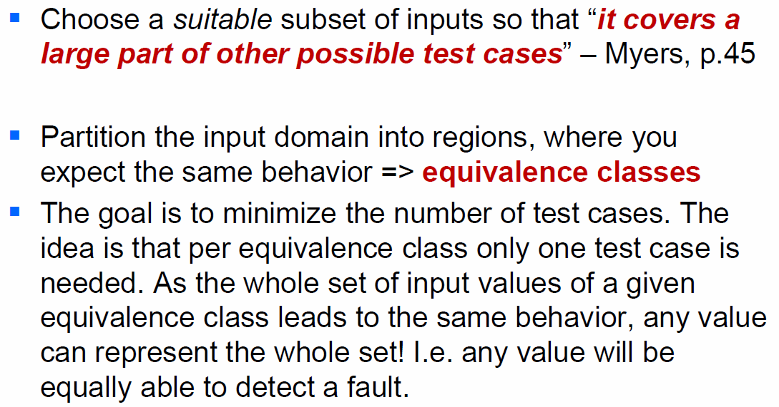

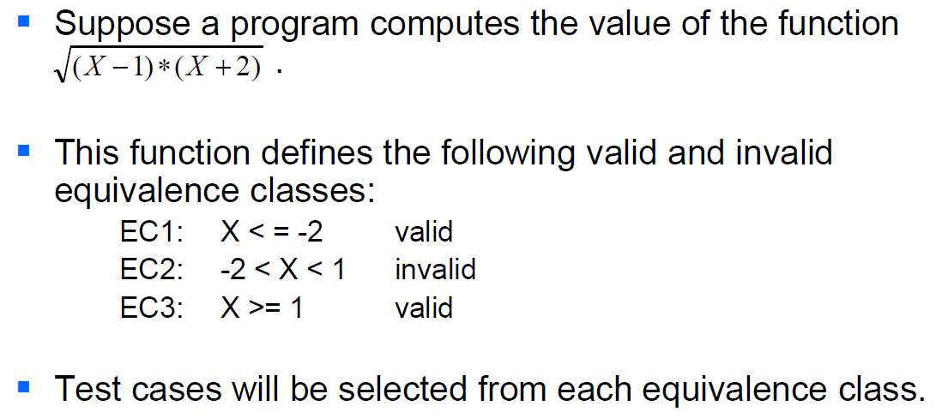

### Boundary Value Analysis

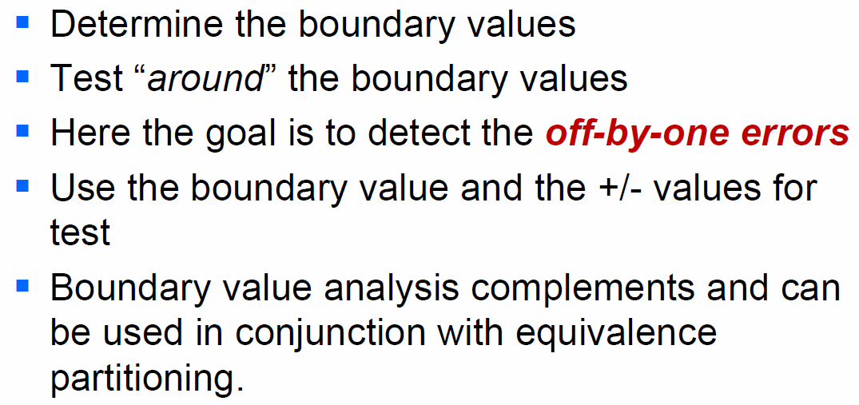

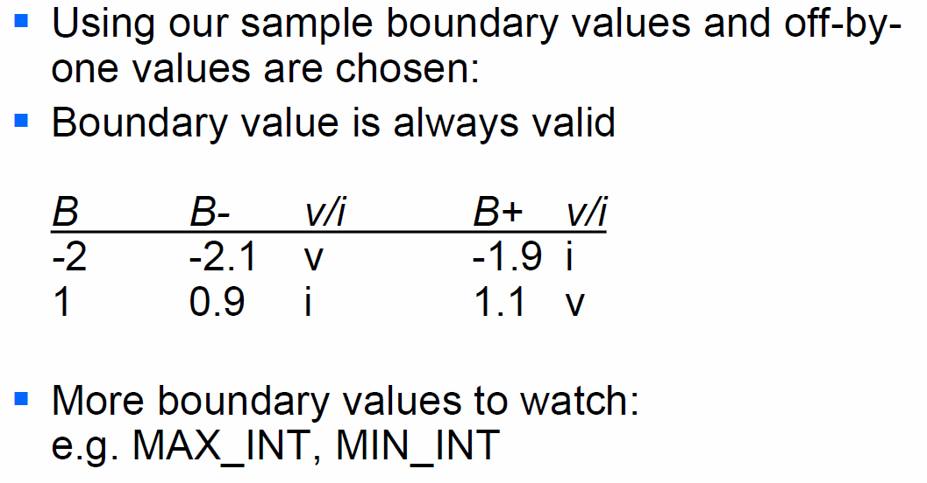

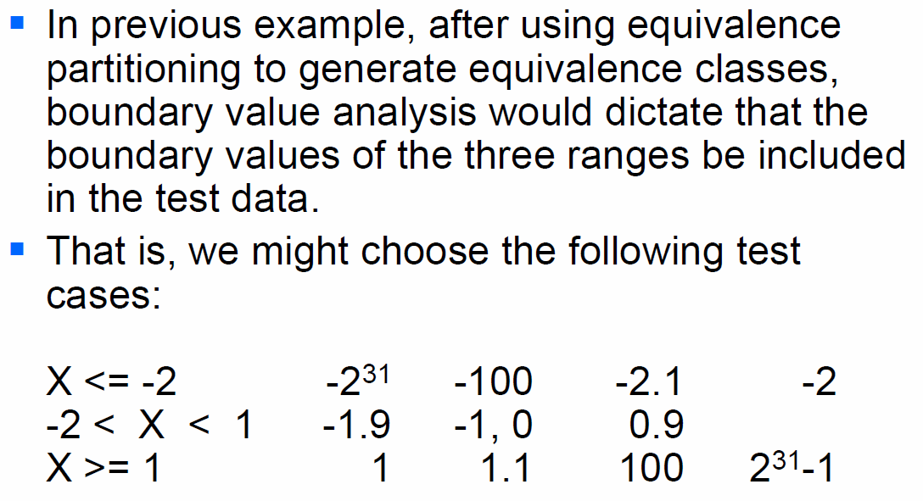

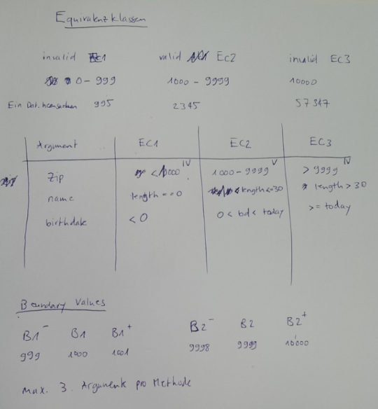

### Acronym Right BICEP

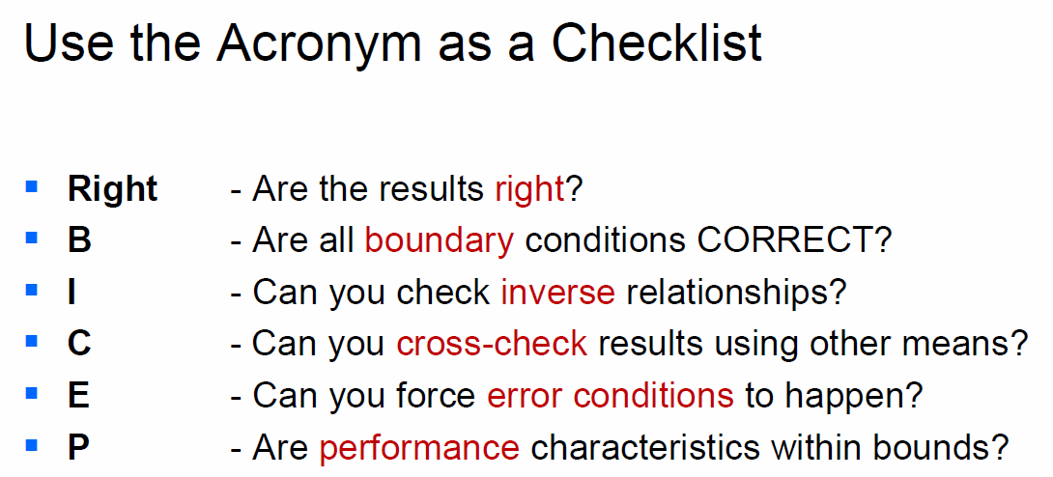

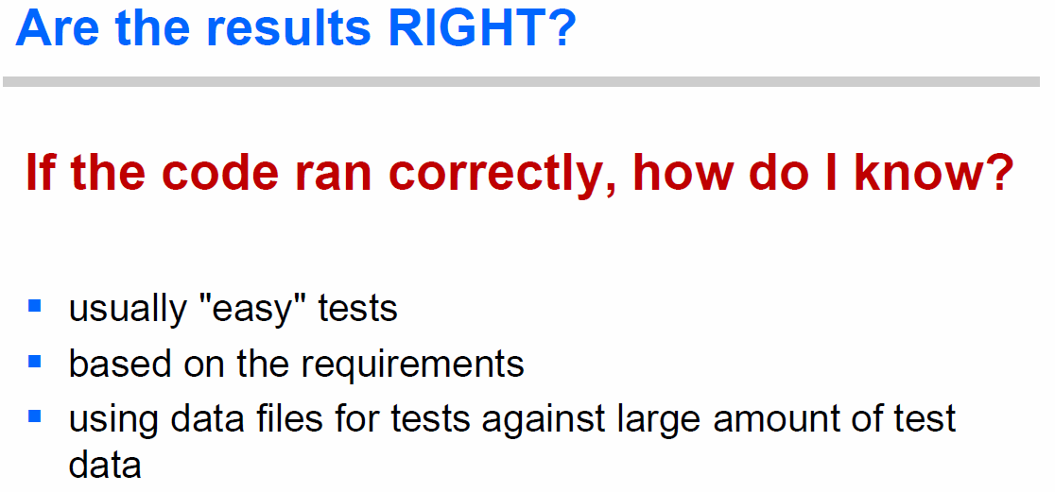

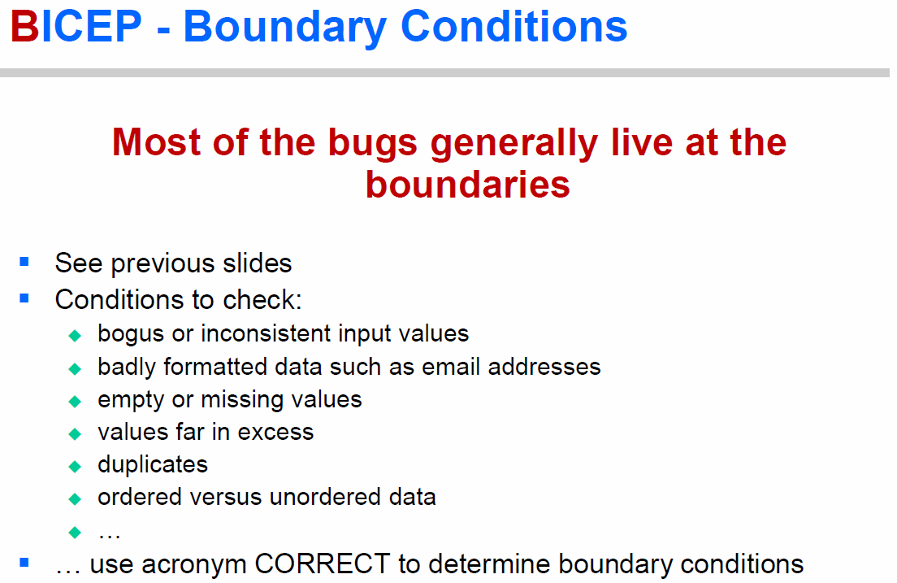

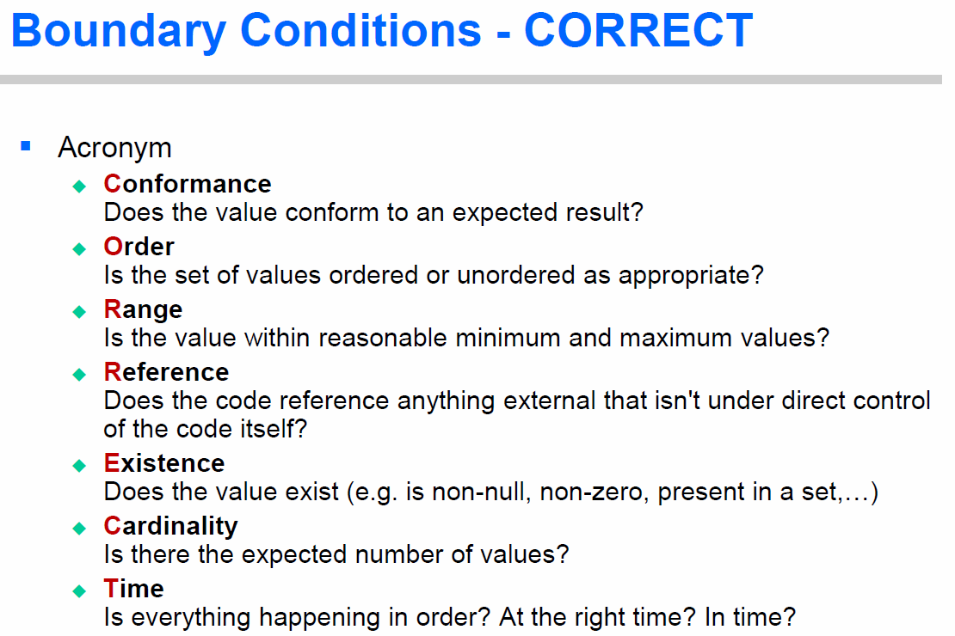

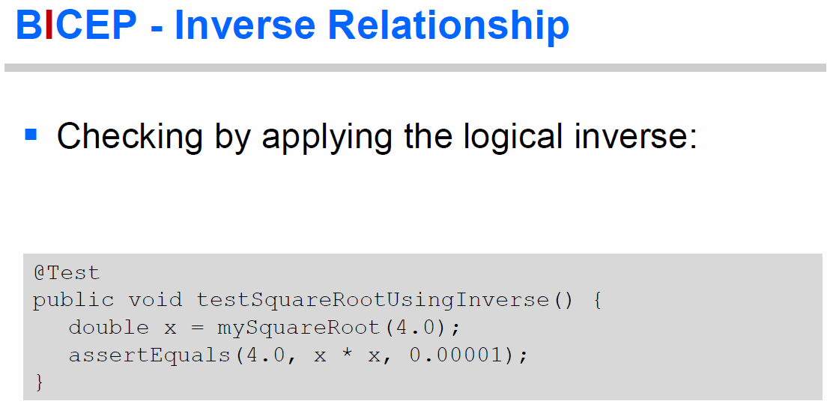

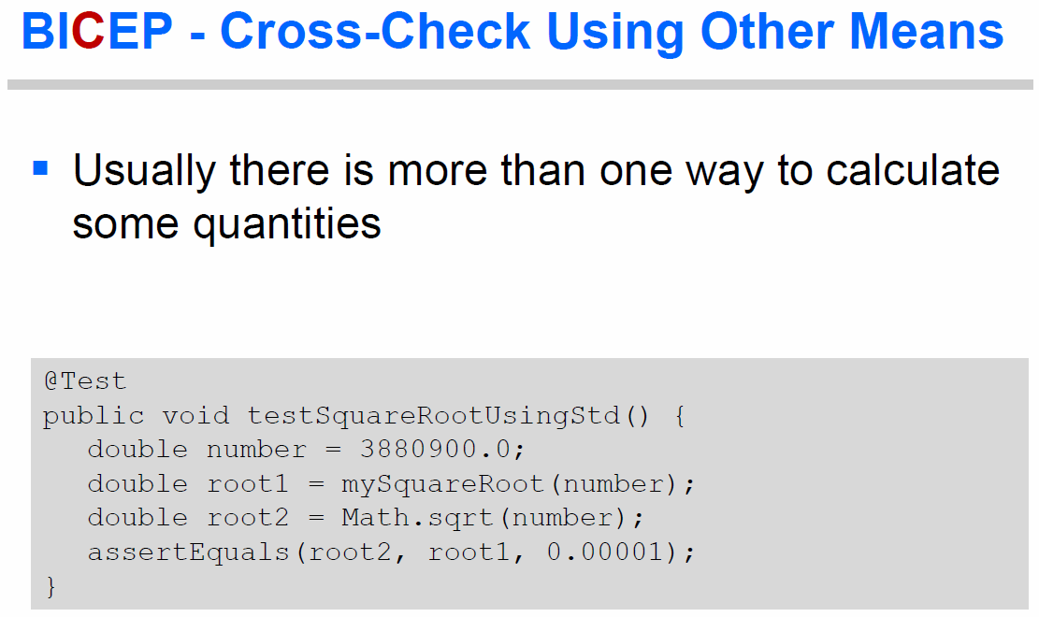

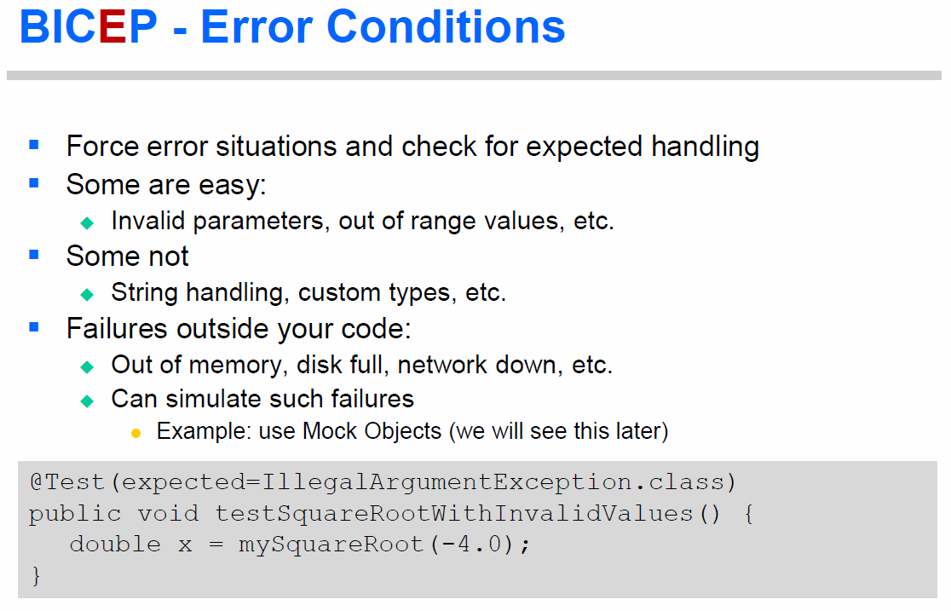

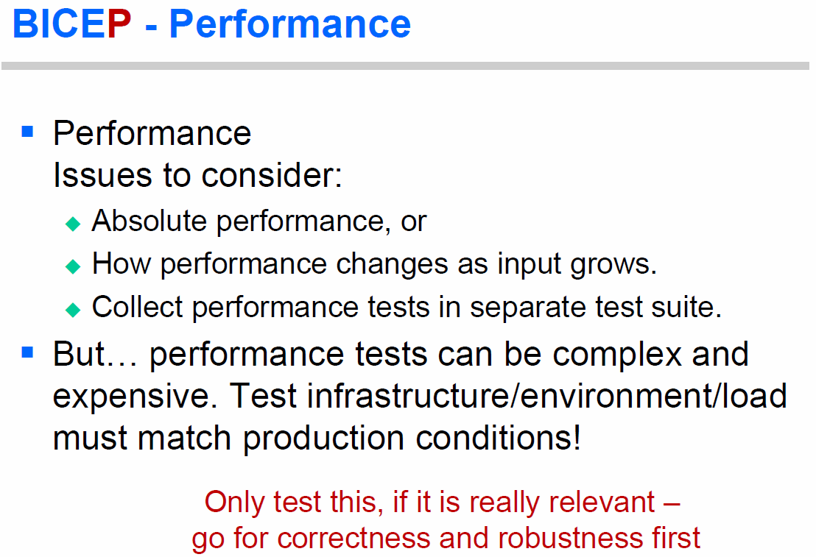

### Test First

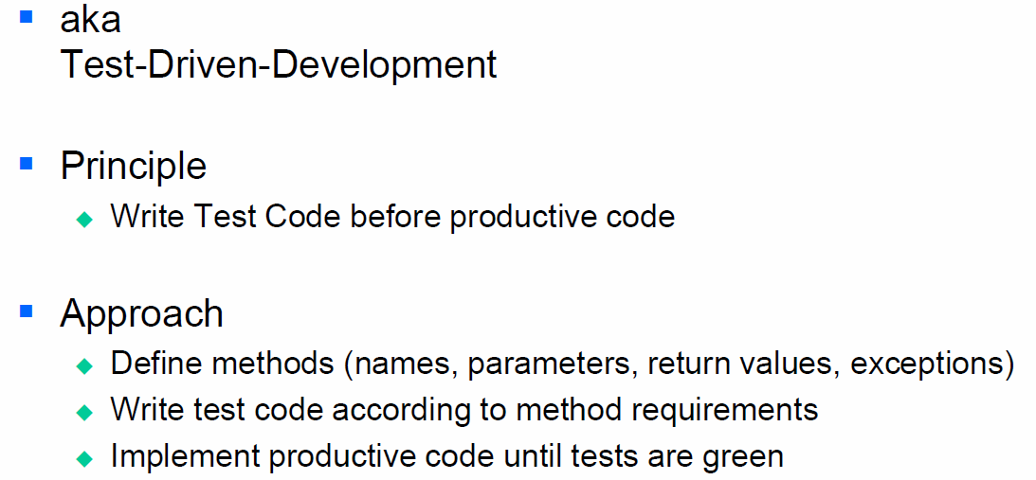

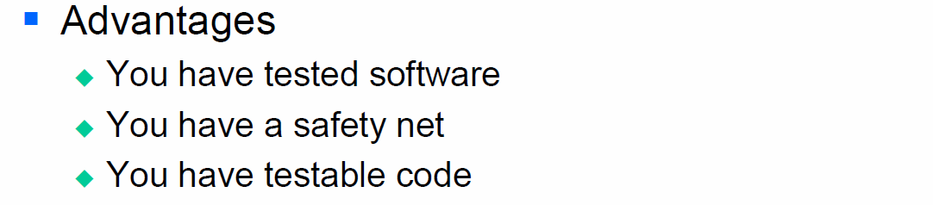

## Writing Testable Code

### What is testable Code?

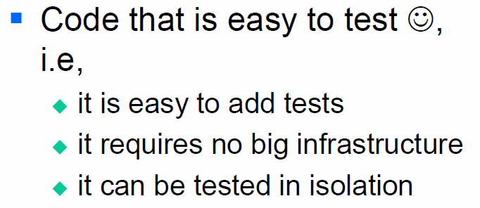

### Some more Terms

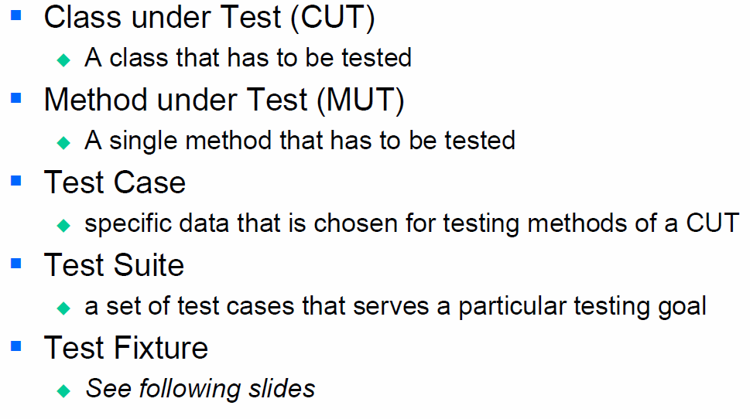

### Fixtures

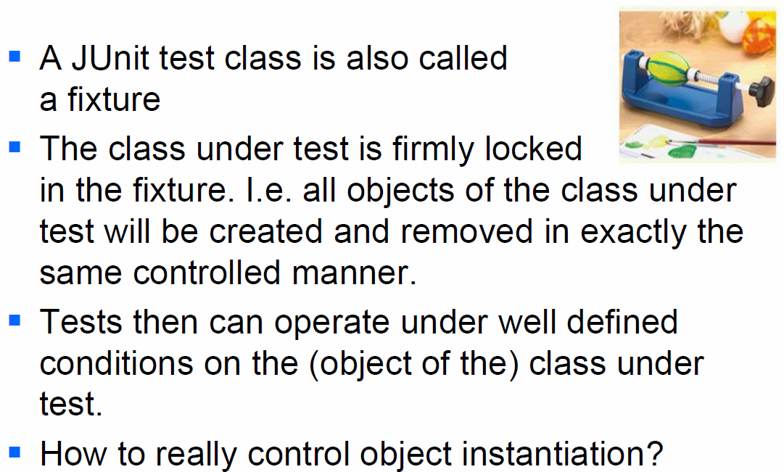

### Fixture

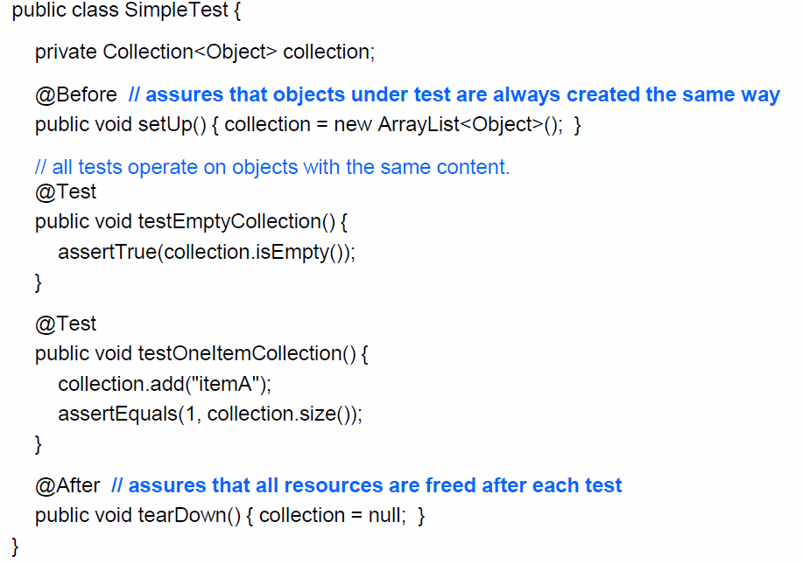

### Testing in Isolation

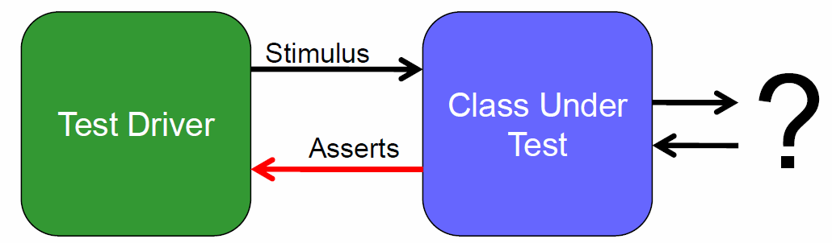

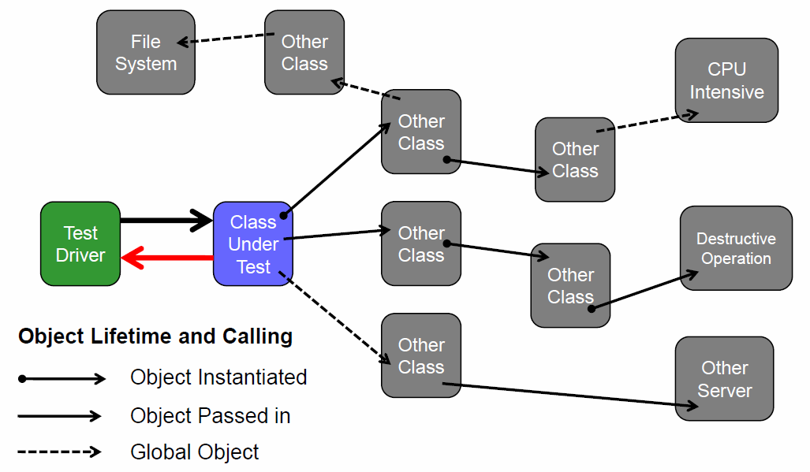

# Woche 11

## Unit Testing

### Unit Testing

* Unit testing is done:
  + On each module
  + In isolation
  + To verify the unit’s behavior
* Unit test will:
  + Establish some kind of artificial environment
  + Invoke routines in the module under test
  + Check the results against known values

### Limits of Unit Testing

* Some things are difficult to test in isolation:
  + Configuration
  + Database access
  + Network access
* In general:
  + How to test a class that depends on other components?

## Mocking

### Test Isolation

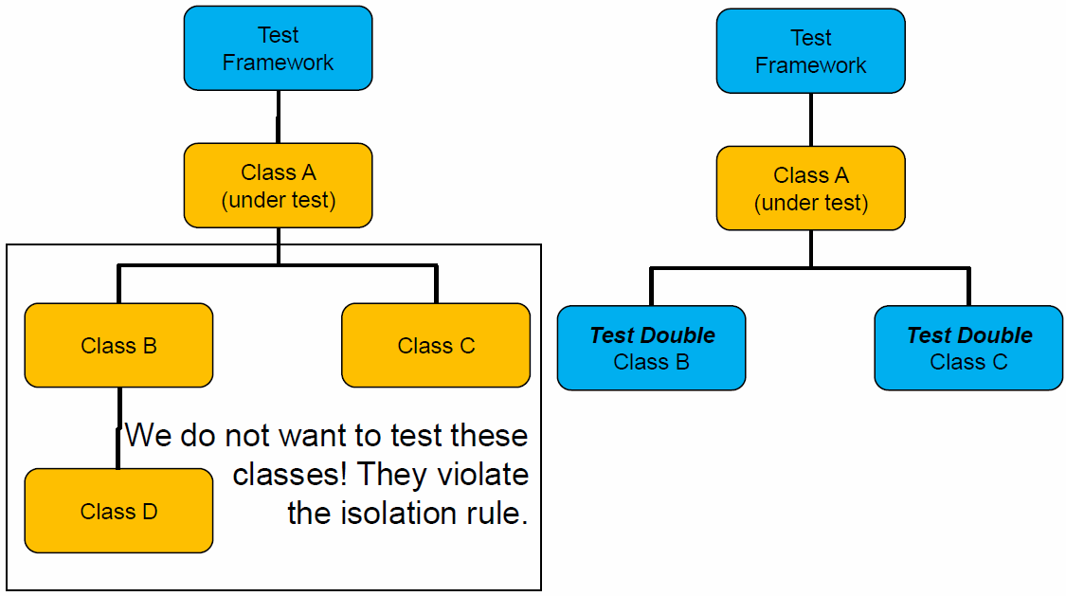

### Test Double

A Test Double is any object or component that is installed in place of the real component for the express purpose of running a test.

### Test Doubles in Unit Testing

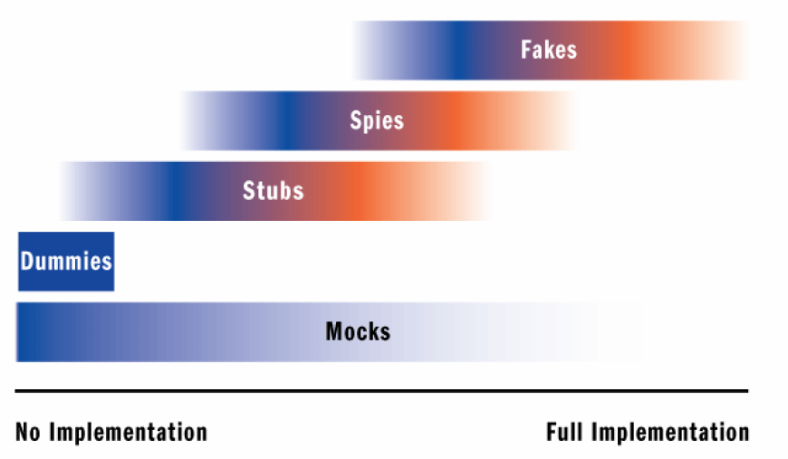

* Dummy objects are passed around but never actually used. Usually they are just used to fill parameter lists.
* Stubs are minimal implementations of interfaces or base classes. Methods returning void will typically contain no implementation at all, while methods returning values will typically return hard-coded values.
* Spys similar to a stub, but a spy will also record which members were invoked so that unit tests can verify that members were invoked as expected.
* Fakes contain more complex implementations, typically handling interactions between different members of the type it's inheriting.
* Mocks objects pre-programmed with expectations about the methods that will be invoked. The expected arguments for a call and the resulting return values or exceptions

### Testing with Stubs

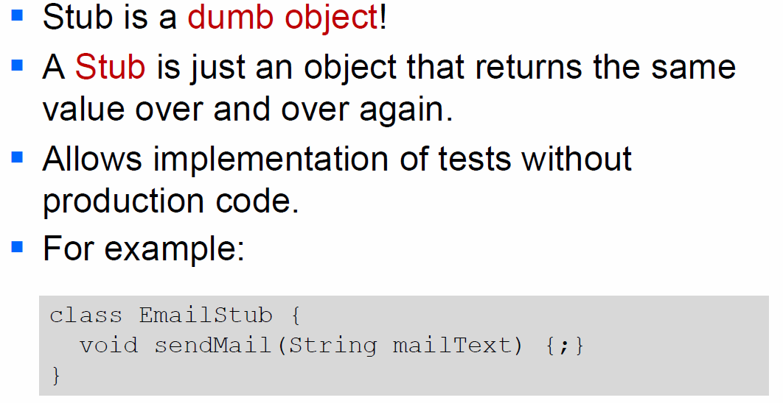

### Sample Application

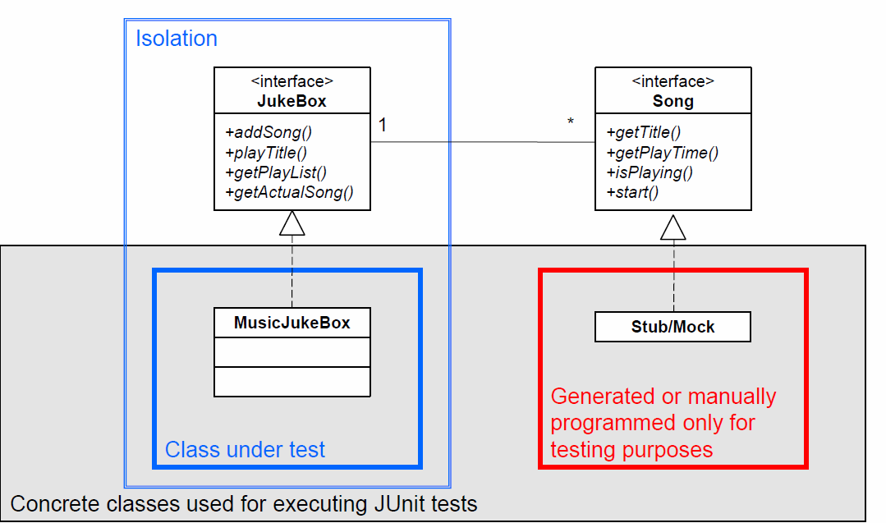

### Mock Testing

* Mock objects simulate parts of the behavior of domain objects
* Classes can be tested in isolation by simulating their collaborators with mock objects
* Takes classes out of a production environment and puts them in a well-defined lab environment

### When to Use Mock Objects

* The real object has non-deterministic behavior
* The real object is difficult to set up
* The real object is slow
* The real object has a user interface
* The test needs to ask the real object about how it was used (🡪 if callback function was called)
* The real object does not yet exist

### Pros and Cons of Mock Objects

* Pros:
  + Enforce the message that testing is about isolation
  + Can simplify working with interfaces with many methods
  + Can enable near-instant testing even of code that uses resource-bound APIs such as JDBC
* Cons:
  + Can mirror the implementation too closely, making the test suite fragile
  + Mocking can become complex with APIs like JDBC

## Mock Framework Mockito

### Overview

* Writing and maintaining mock objects often is a tedious task that may introduce errors.
* Mockito is a library that provides an easy way to use mock objects.
* Mockito generates mock objects dynamically -no need to write them, and no generated code
* https://code.google.com/p/mockito/

### Using Mockito

* Test scenario:
  + We want to test the getActualSong() method of the class MusicBox
* Isolation:
  + We have to “mock” the class Song and emulate its behavior

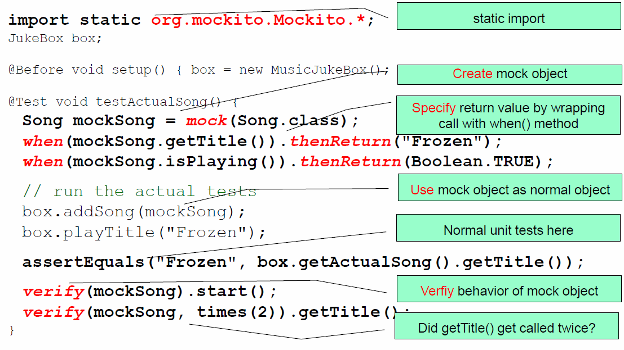

### Mocking Usage Pattern

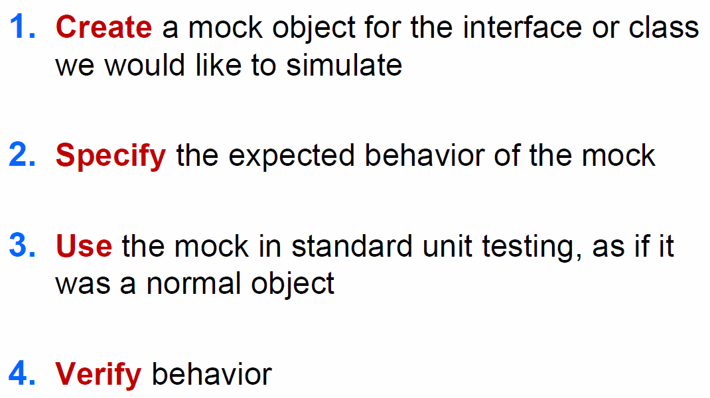

### Create Mock

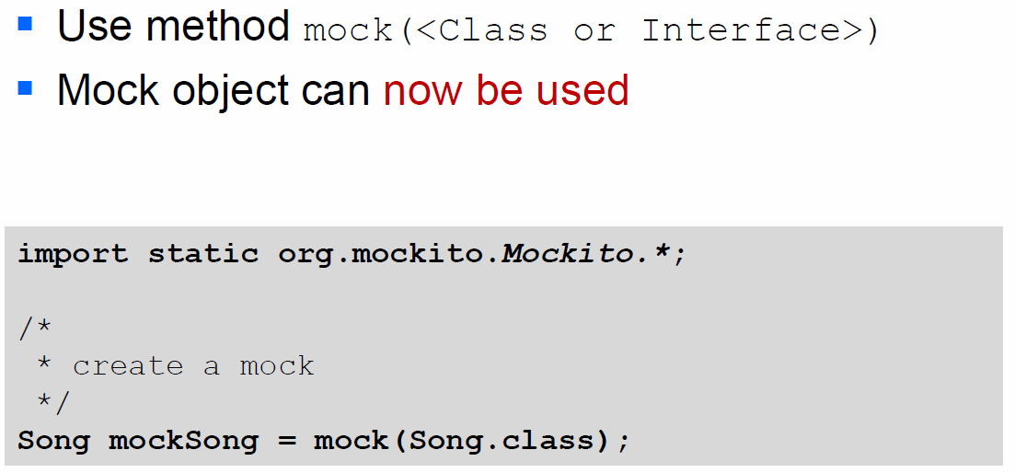

### Specifiy Method Behaviour

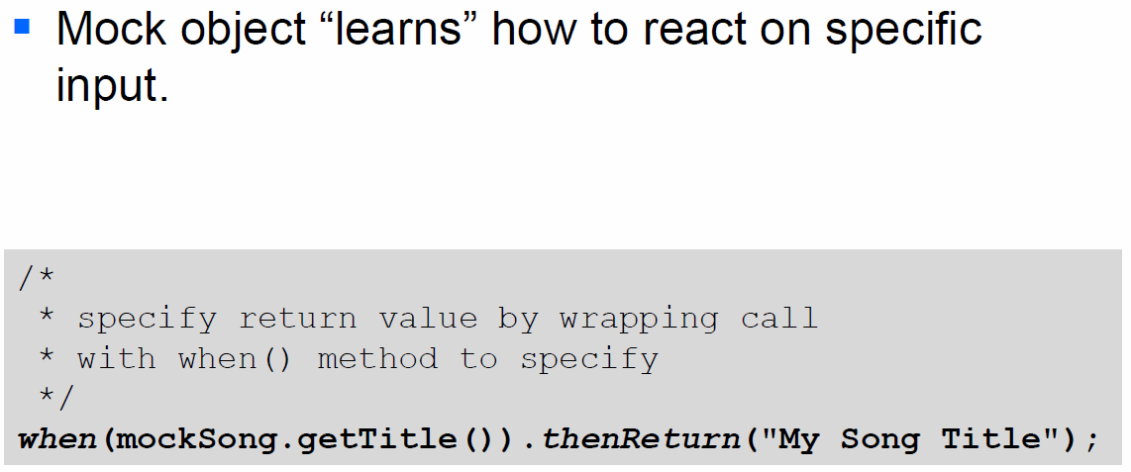

### Use Mock Objects

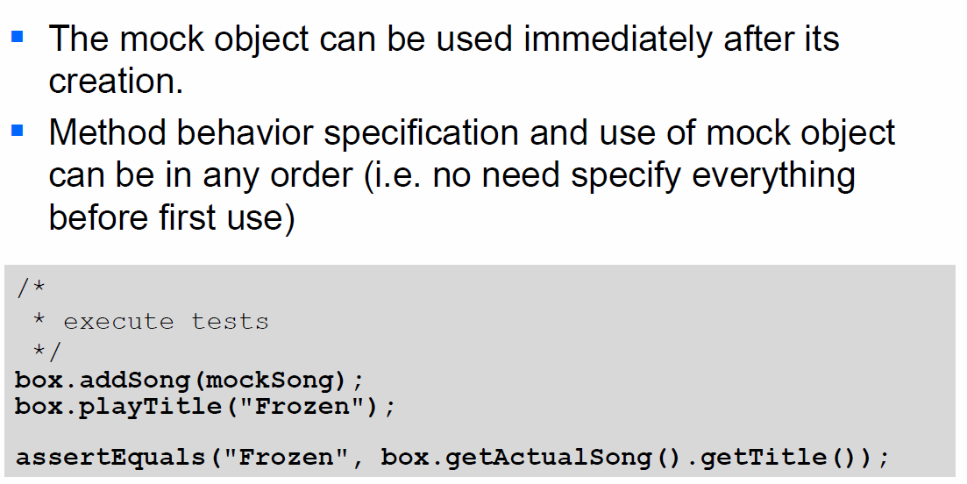

### Verify Behavior

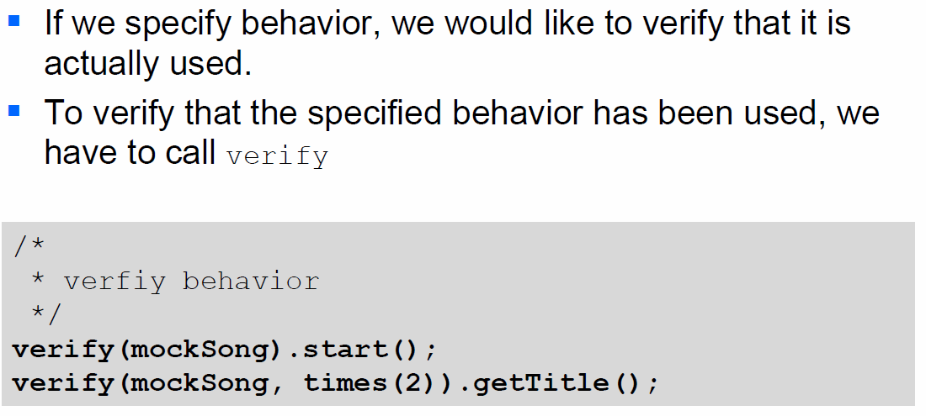

### Mockito Benefits

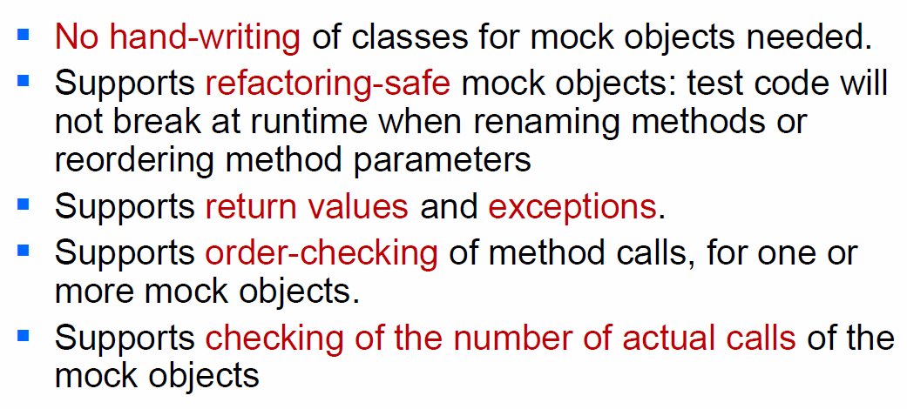

### Further Concepts

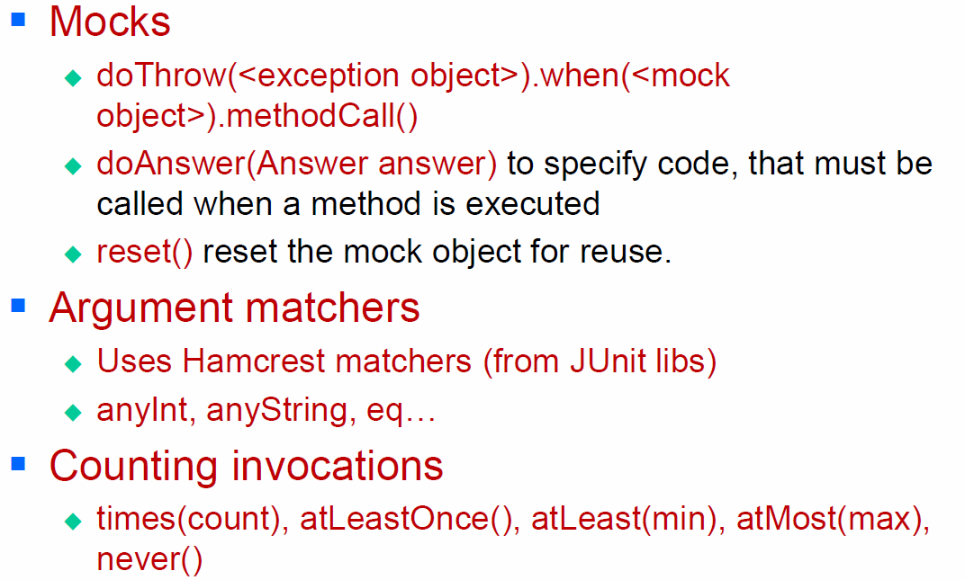

# Woche 12

In Woche 12 fand aufgrund der Projektwoche kein Unterricht statt.

# Woche 13

In Woche 13 wurde das Mockup Testing mittels Mockito weitergeführt.

# Woche 14

In Woche 14 hatten wir die Möglichkeit, am Milestone 6 zu arbeiten.

# Woche 15

## Code Quality

### What is Software Quality

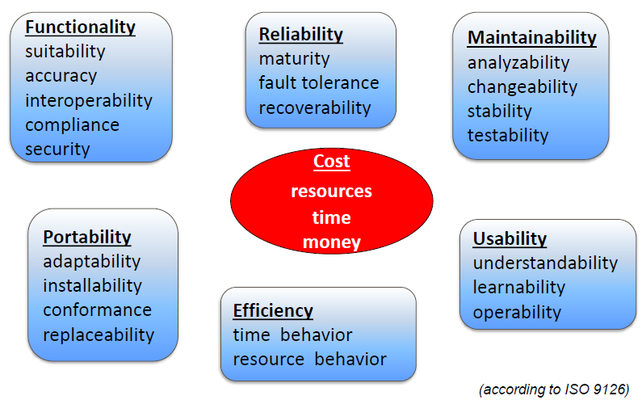

### Software Quality Goals – Beware

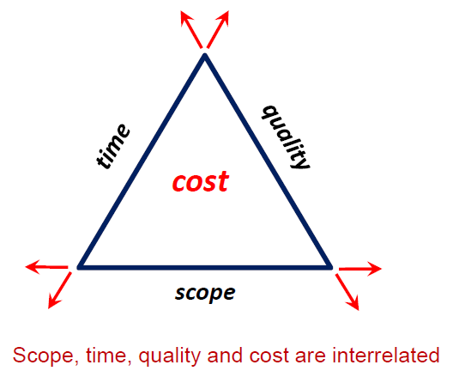

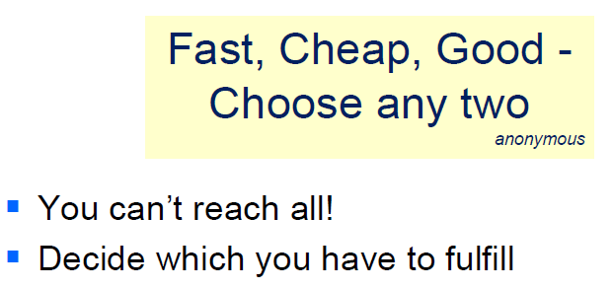

### Software Quality - Management

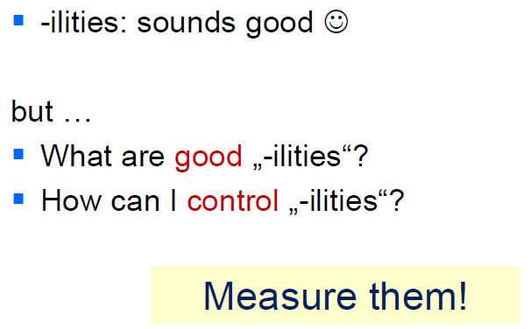

## Metric Data

### Metric: A Definition

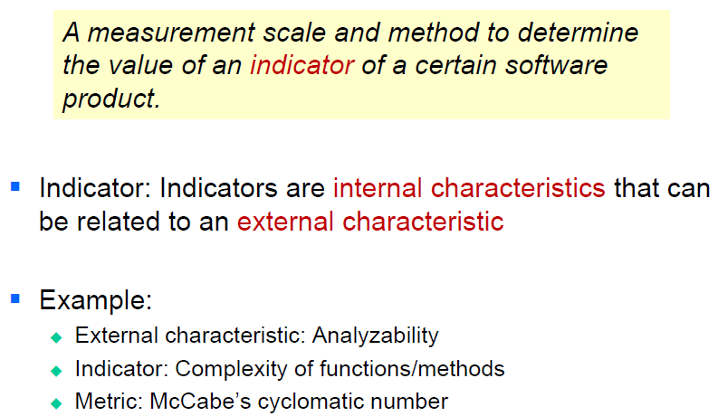

### What Can We Measure

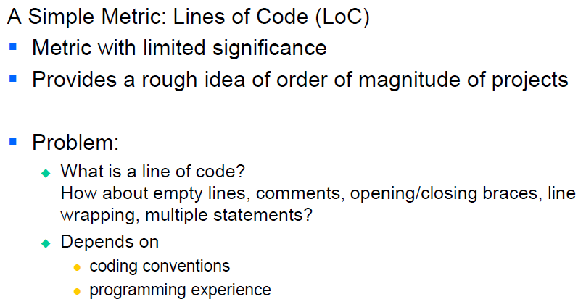

### Some Static Software Metrics

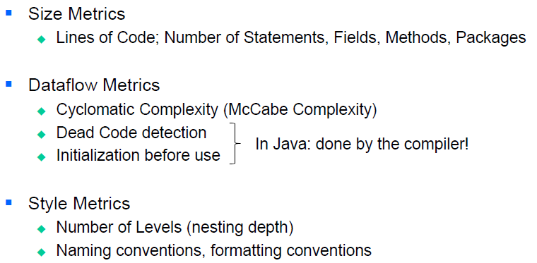

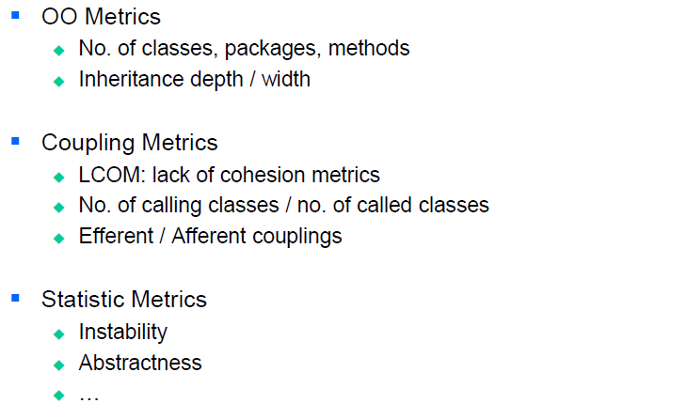

### Some Dynamic Software Metrics

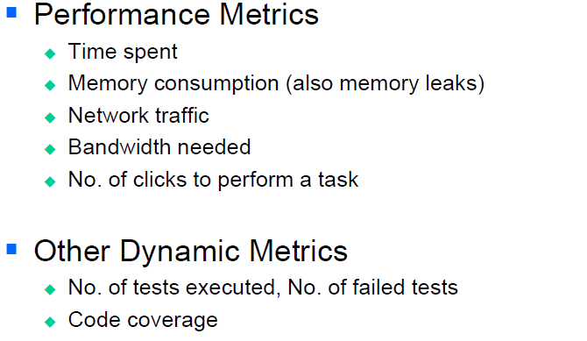

### What else we can measure

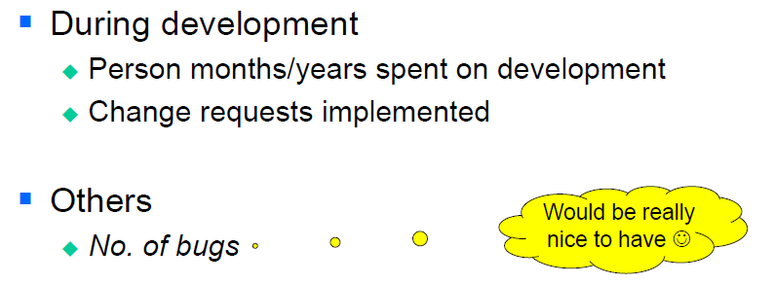

### Cyclonic Complexity (McCabe)

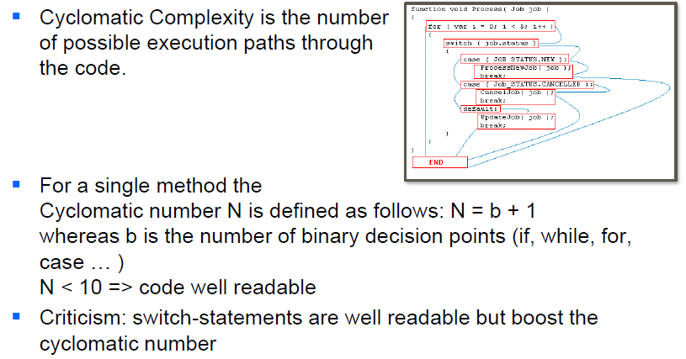

### Cohesion and Coupling Metrics

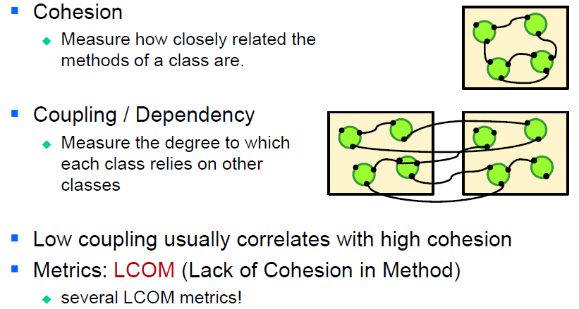

### LCOM

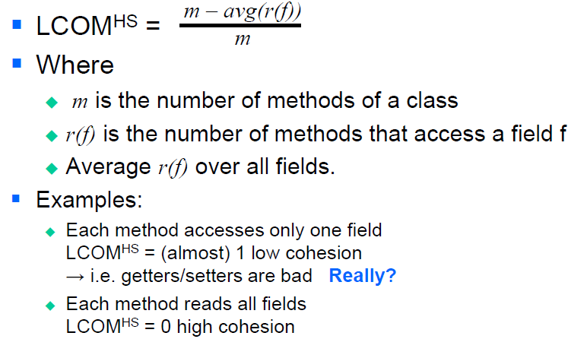

### Measure What You Test

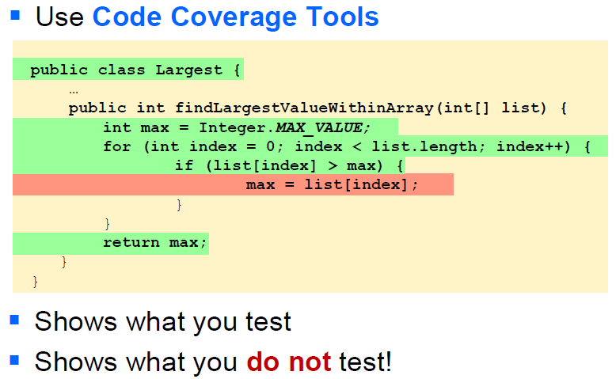

### Measurements Units

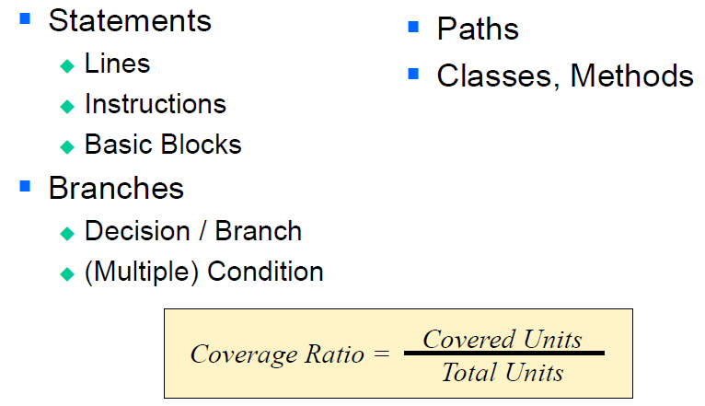

## Tools

### Some Sample Figures

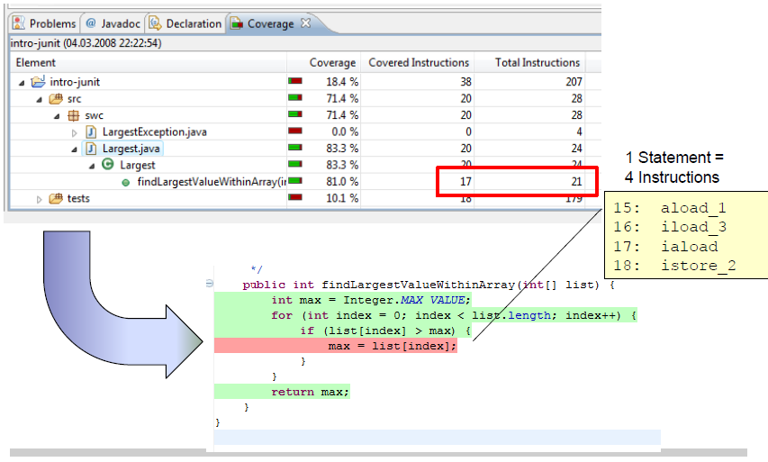

### How is coverage measured

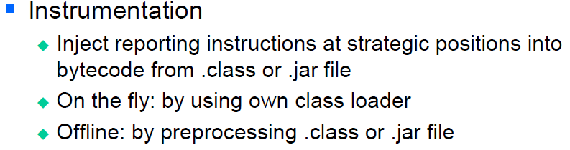

### Instrumentation

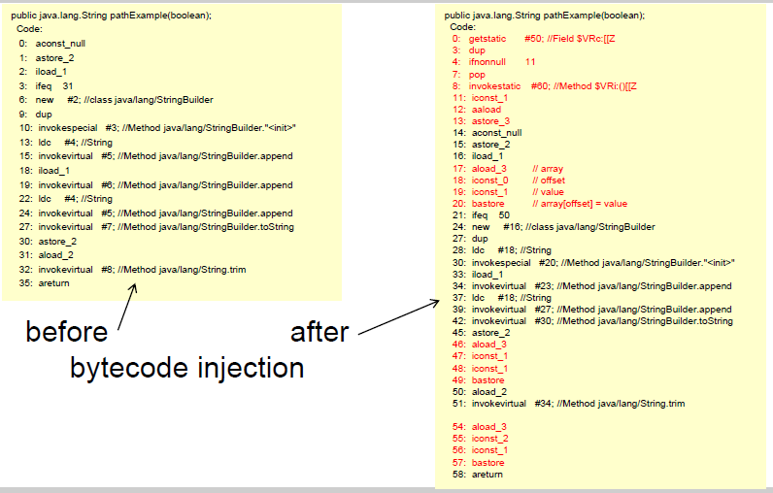

### Code Coverage with Emma

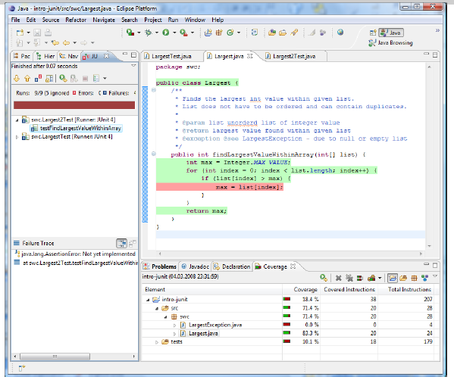

### Emma Features

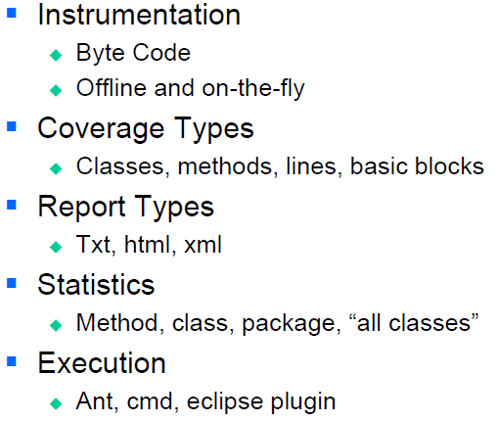

### Using Metrics

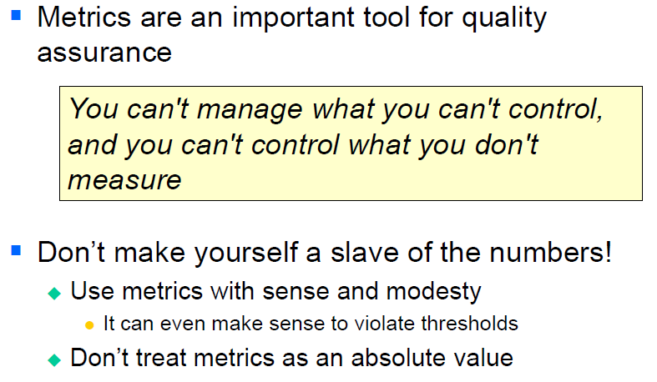

### Resources

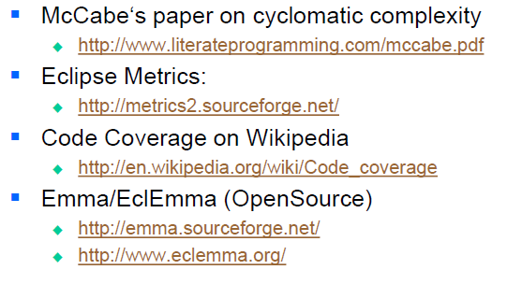

# Woche 16

## Refactoring

### Improving Code

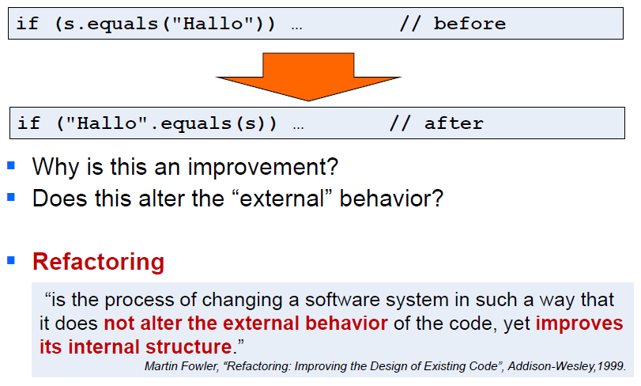

### If it stinks, change it

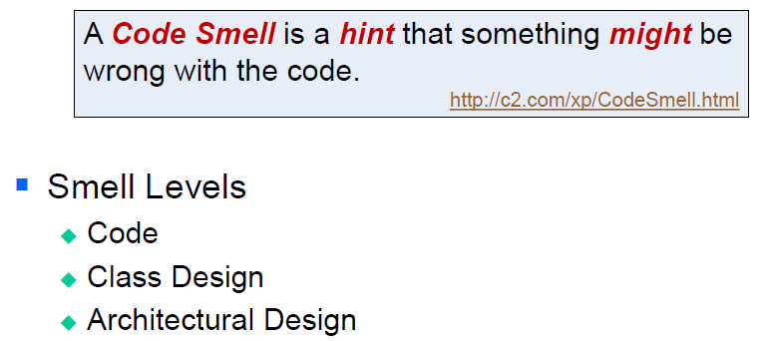

### How do I find Code Smells?

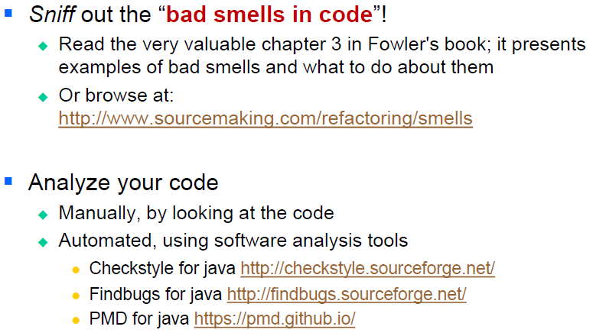

### Some Typical Code Smells

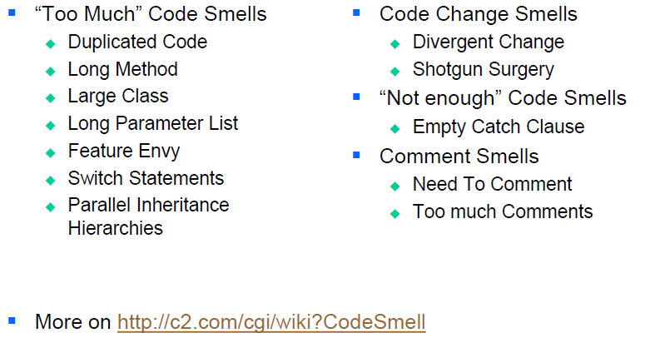

### Why Refactoring

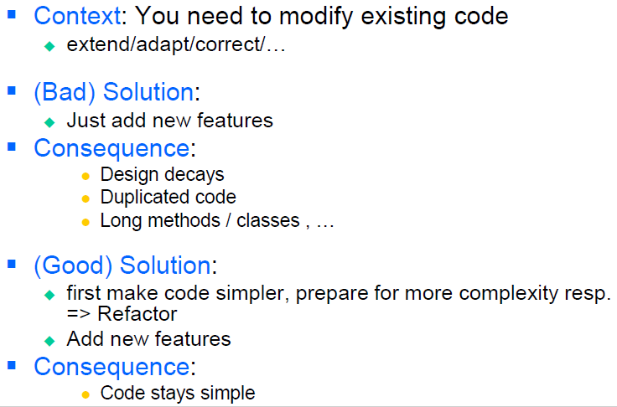

### Benefits of Refactoring

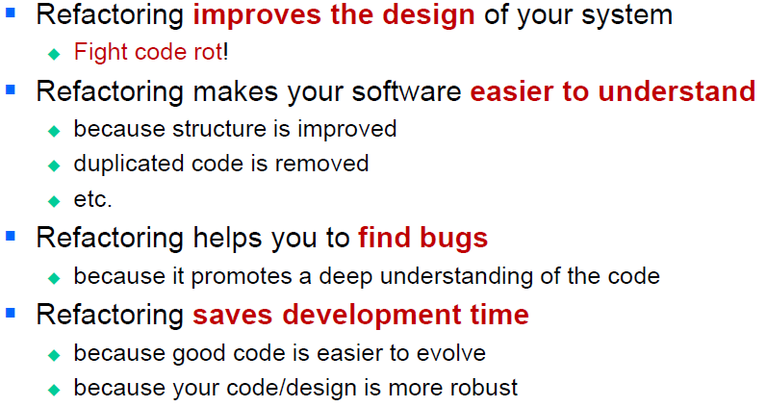

### Prerequisites for Refactoring

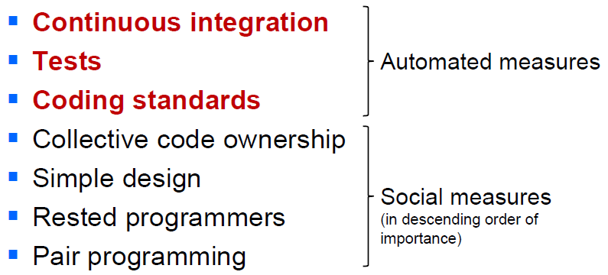

### The Two Hats

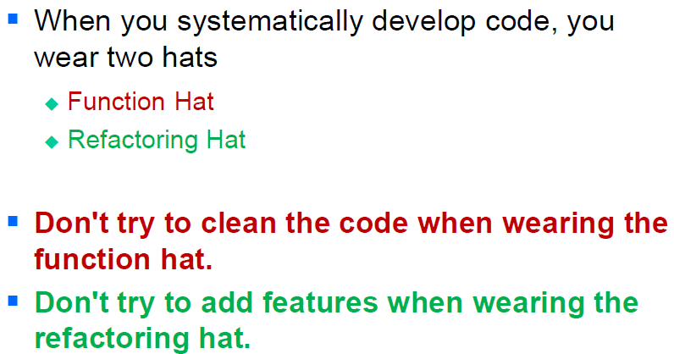

### Refactoring Workflow

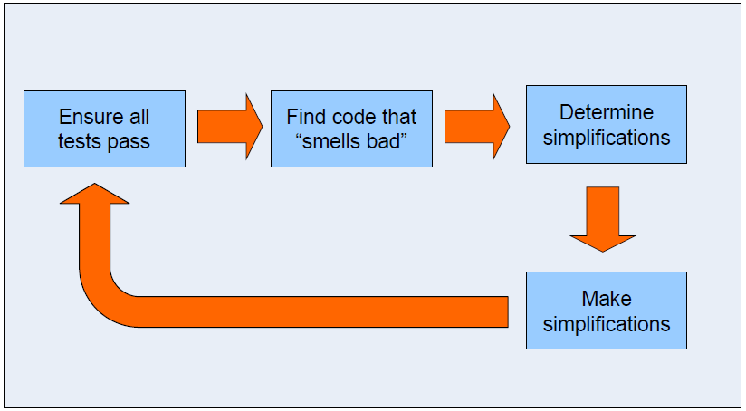

### When

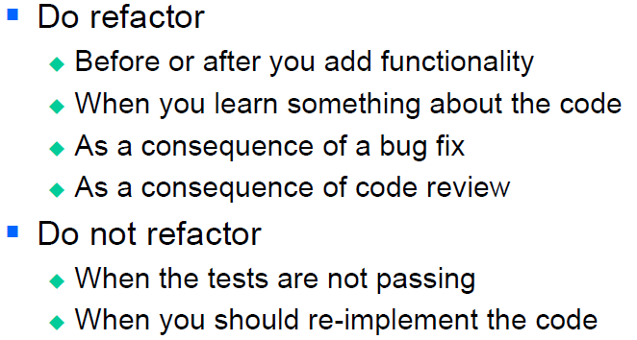

### Problems with Refactoring

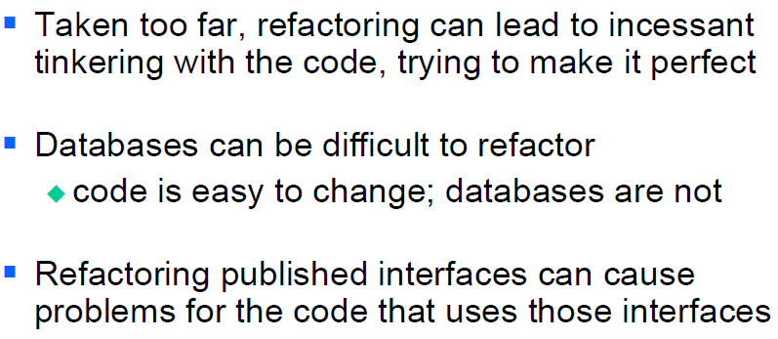

### Resources

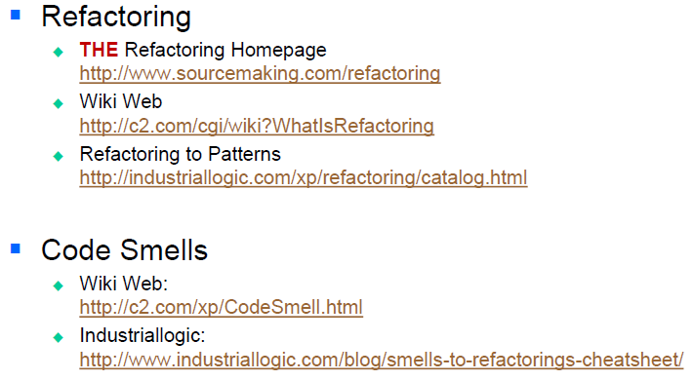

# Woche 17

## Logging

### Why logging?

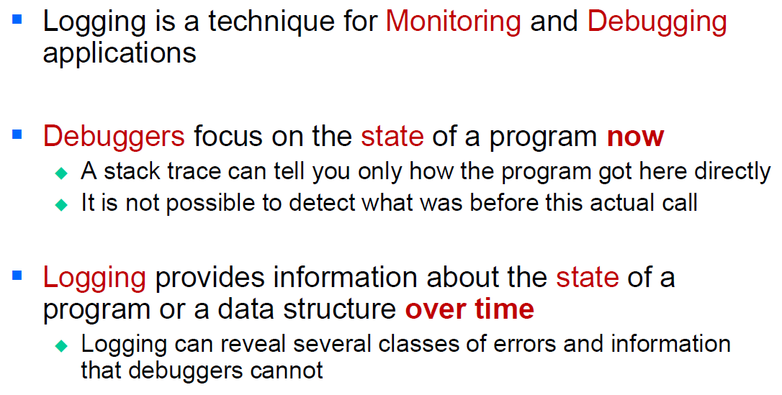

### Value of Logging

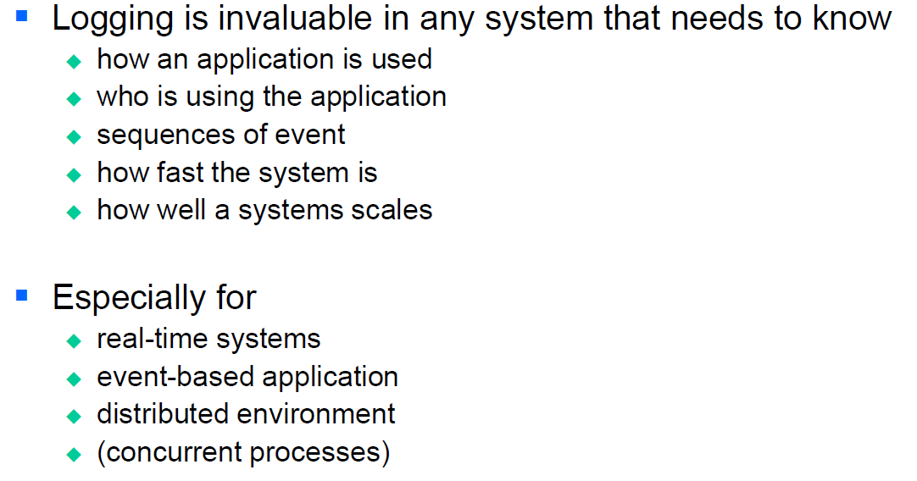

### Approaches to Logging

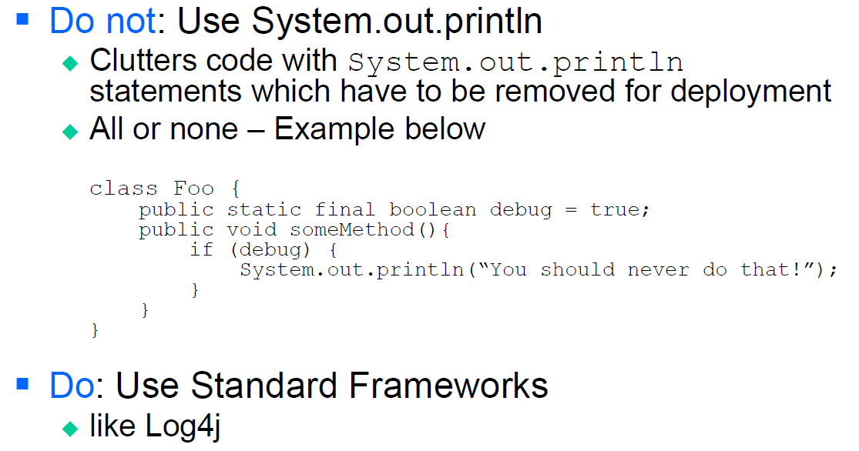

### Benefits Using Logging Frameworks

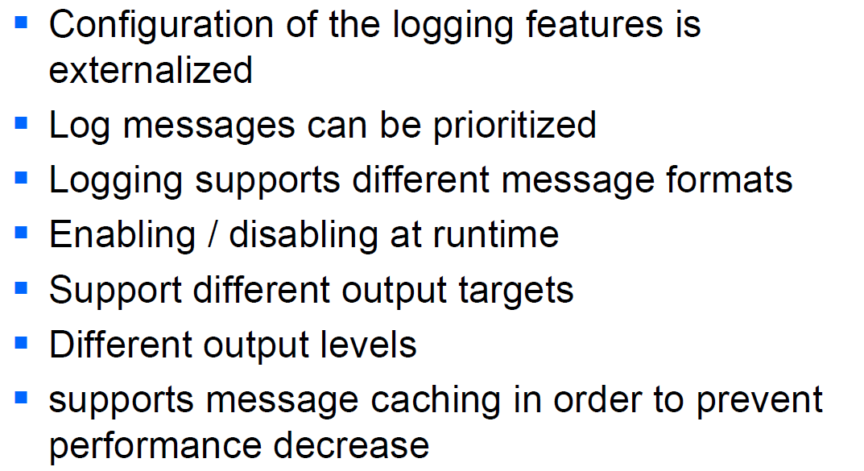

## The log4j Framework

### Overview

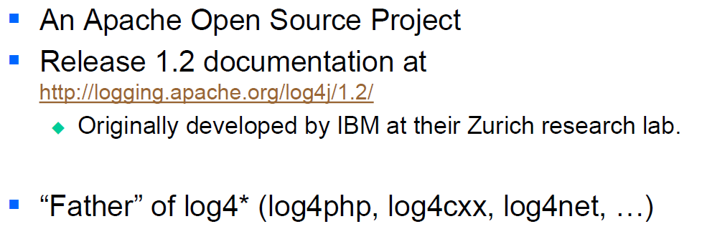

### Example

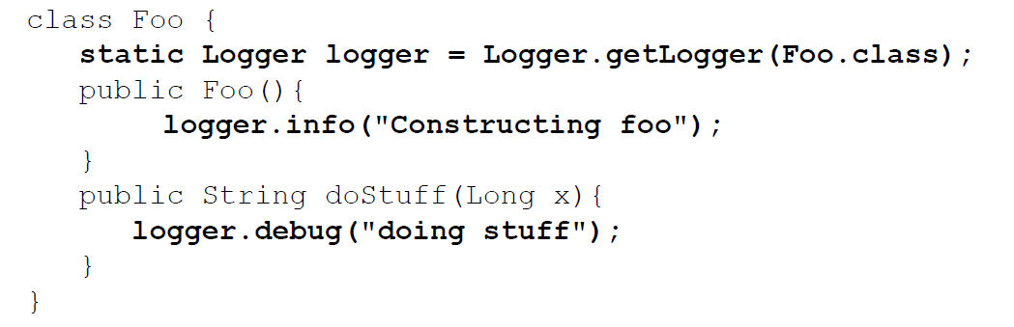

### Concepts

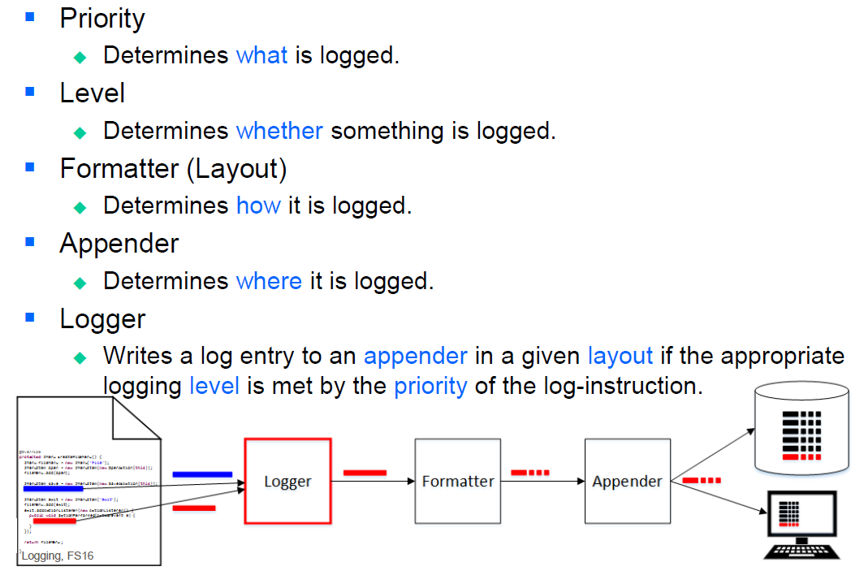

### Logging Levels

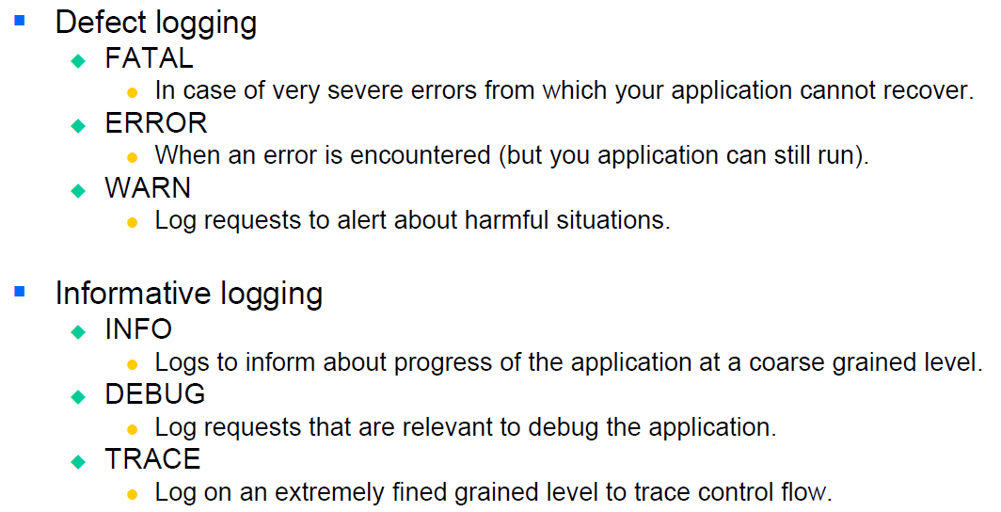

### Logging API

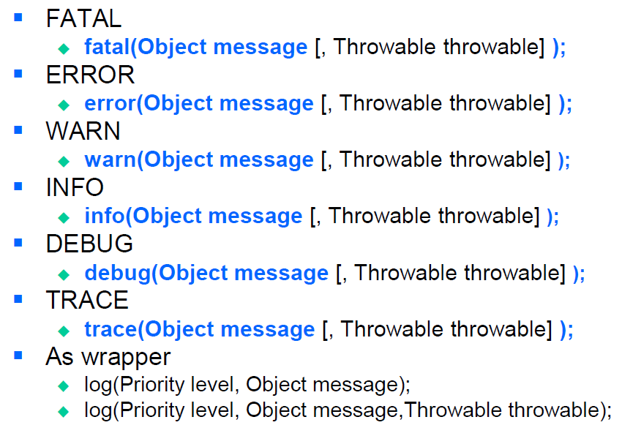

### Loggers, Appenders and Layouts

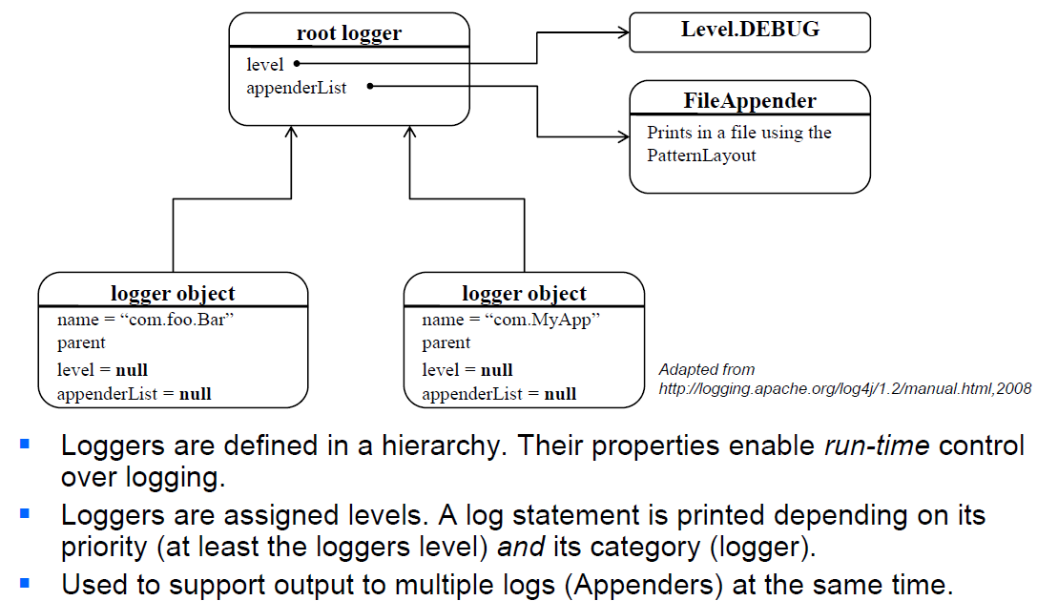

### Logger Names

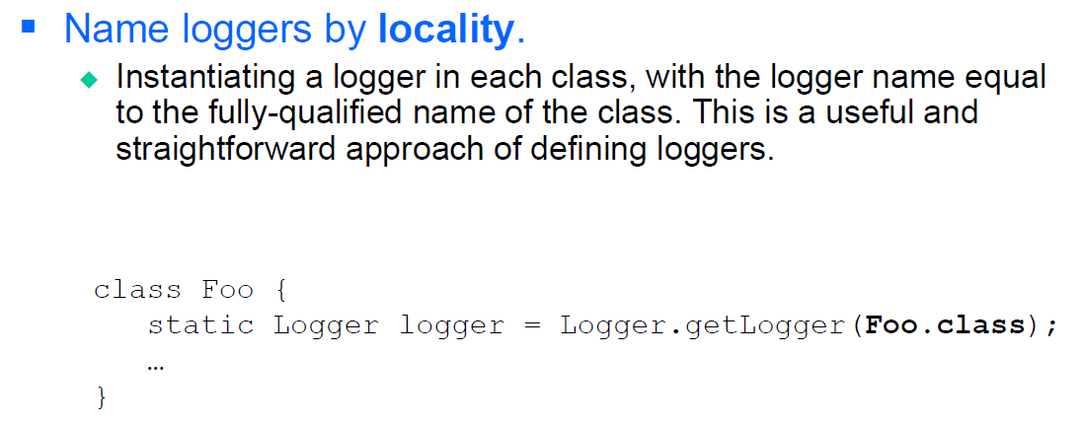

### Benefits of using Fully Qualified Class Names

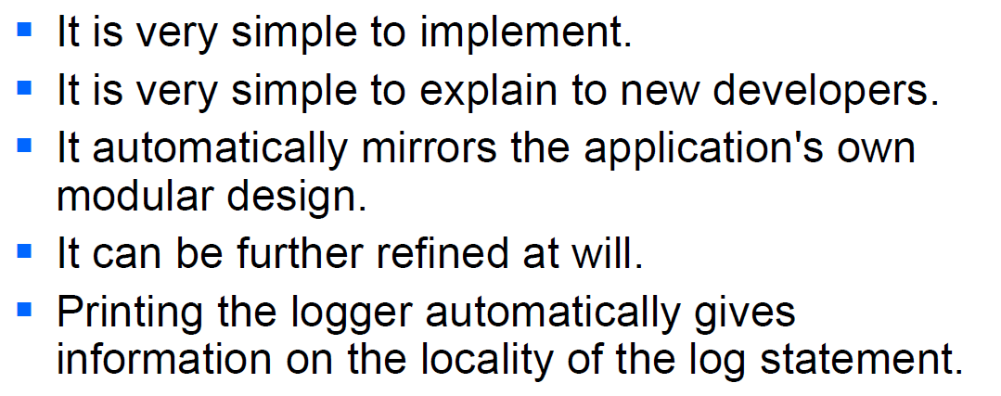

### Rooter Logger

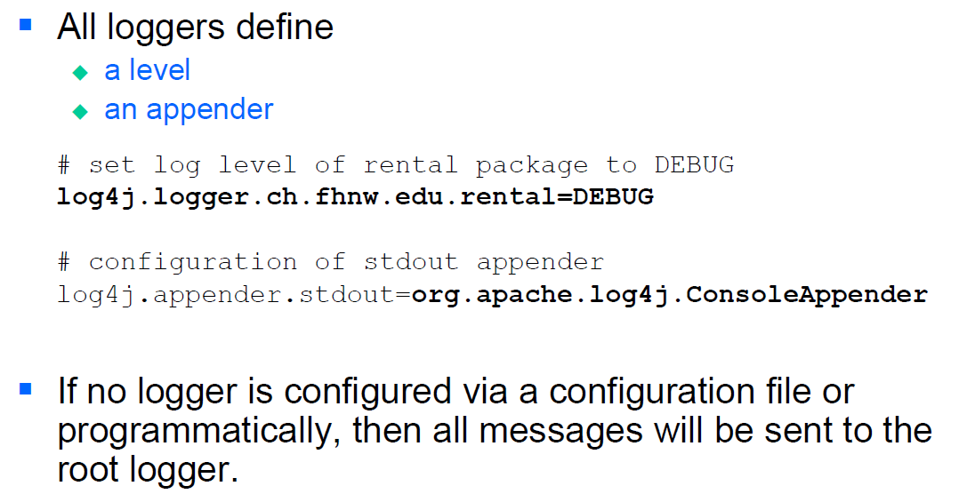

### Appenders

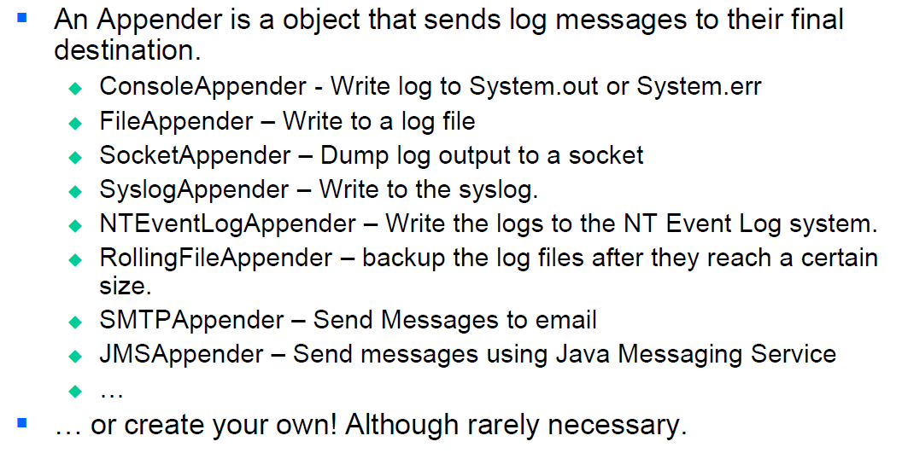

### Pattern Layout – Customize your Message Format

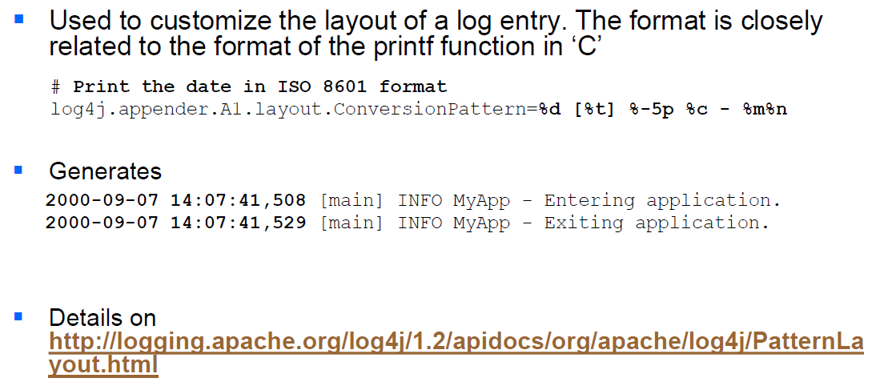

### Sample log4j.properties

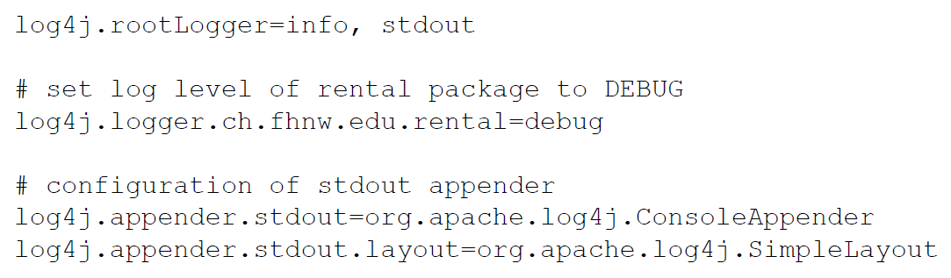

### Sample log4j.xml

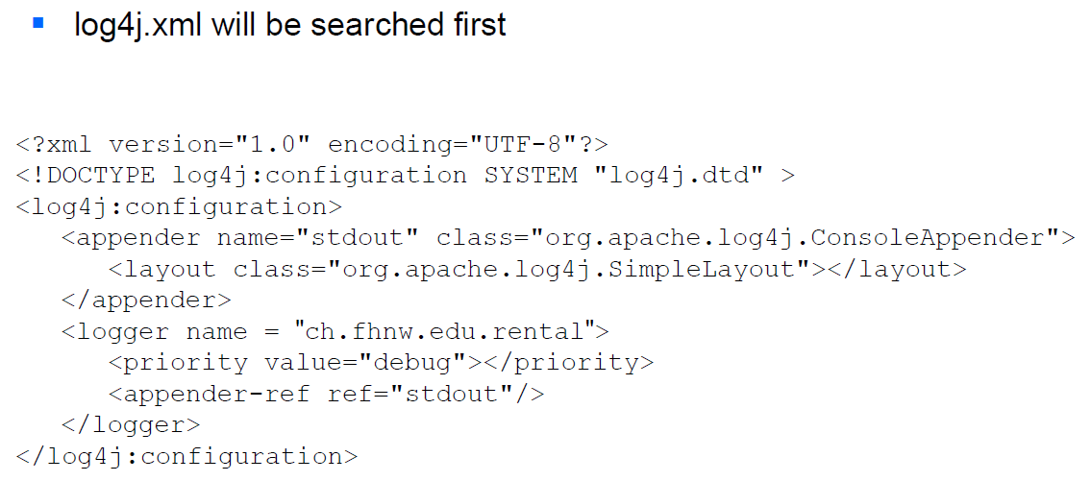

### Cost of Logging

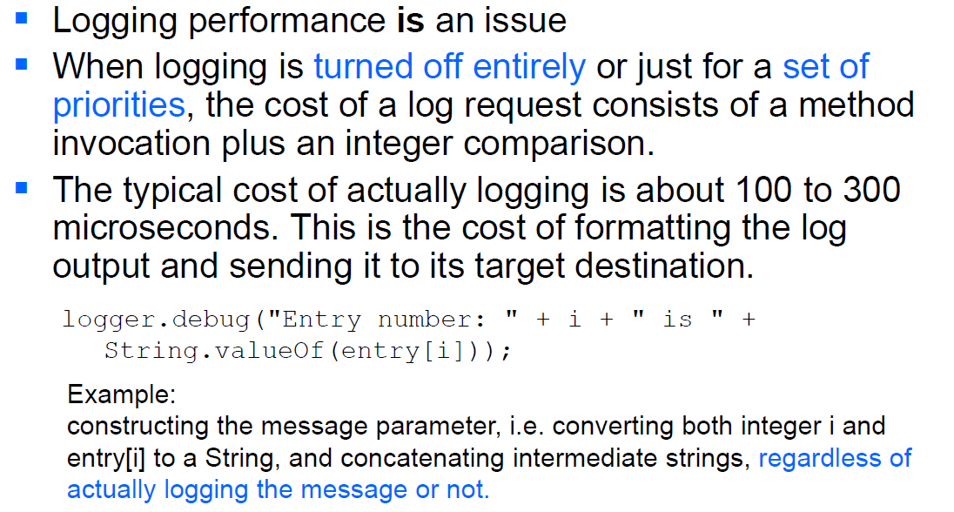

### Hidden Costs of Logging

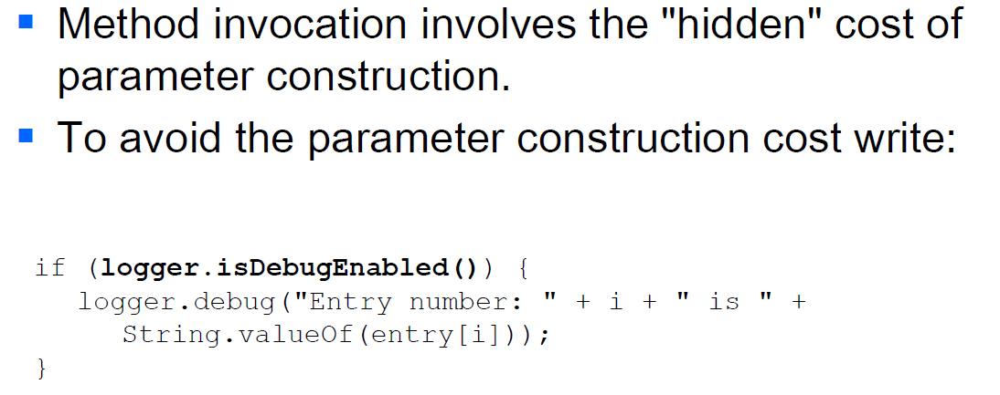

### Some Best Practices

